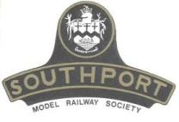 | Southport Model Railway Society  Newsletter  No 35: October 2014 Editor- Ian Shulver (i.shulver@btinternet.com)

Chairman’s notes:
As you will have noticed our monthly newsletter failed to hit the news stand for the month of September. Unfortunately we were beset by a series of administrative difficulties and technical problems all of which contributed to its non appearance. In the meantime, whilst these problems are being resolved Ian has prepared material in order to produce this, the October issue, in time to herald our next monthly talk which will be a slide presentation on the railroads of Colorado and presented by an outside speaker. I am sure you will find this well worth seeing.
Whilst still looking forward into the coming months it is a timely reminder of course that next month sees our own model railway show at Birkdale High School and hopefully you will all be able and available to once again give your invaluable support as you have in the past. Please make a note in your diaries for 8th & 9th November.
Also on the subject of activities during the coming months is the remedial repairs/decoration of the club rooms, work continues at a steady pace, however there is still much to do. appreciate that we are coming to the end of the holiday period so attendance has been low but I would ask for whatever skills and support you can offer in order to bring our Club back to it's former excellent standard. Thank you.
Frank

***********************
Monthly talks:
The August talk was at Jim Ford’s where he, and co-opted colleagues, provided instruction in the mysterious art of firing and driving radio controlled 16.5mm steam locos. On a very windy evening, and with an earlier start in order to make best use of daylight hours, Jim firstly outlined the various types of model steam engines – externally and internally fired using meths, solid fuel pellets or propane/butane, and simple oscillating pistons or the fancier ones fed via Walschaerts valve gear. We then moved on to the practical stuff - fuel/oil/water etc, before putting a light to the firebox (oddly enough by way of the chimney). Eventually after some time heating up the water to produce sufficient steam, we had four operating locos running around the circle of track – not always successfully (there were one or two minor shunts and the occasional derailment due to excessive speed on corners or even invasive ivy). Once we had had our fill (no pun intended) of running trains we were treated to refreshments kindly provided by Fiona. We thank both Jim and Fiona for hosting this event on their wedding anniversary when no doubt they would have preferred to have been going out to an intimate dinner at one of the town’s restaurants, and also to Jim, Tony, Frank and Derek for letting us novices loose on their valuable locos.
The September meeting was given by Derek Pratt and took the form of a travelogue of the June sleeper trip to the apparently sunny climes of Scotland. It was originally intended that the article in this newsletter was to appear before the slide show to wet your appetite for many more views of stunning scenery/locomotives/bridges etc and a commentary deemed to risky to have been committed to print. Many thanks to Derek for his efforts.
Following Derek’s slide show, Jim Ford gave a short presentation on the proposed itinerary for the sleeper trip to Colorado next September. It certainly seems as though it could be an exciting excursion with plenty of opportunities for everyone.
This brings me onto the subject of our next Tuesday talk which will be on 14th October and will be held in the Director’s Suite at Southport Football Club, Haig Avenue. This will be given by a guest speaker, Robin Green and features many slides of the railways in Colorado. It gives a taste of the diverse railway (sorry, railroad!) interest in the area – preserved 3ft, massive mainline trains, preserved standard gauge and some abandoned lines, now dirt roads.

***********************
Layout reports
Portland Street - Upper & Lower (Tony Kuivala). Currently out of commission until the room has been redecorated.
Monsal Dale (Ian Shulver) – No action here. Once redecoration upstairs has progressed a bit more we can start to consider modifying the points in the fiddle yard and station throat..
Talisker Glen. As with Portland Street, Talisker Glen is out of commission until the room has been redecorated. Once completed work on the layout will recommence.
***********************
2014 Exhibition – Tony Kuivala
Continuing with the Layouts that will appear in November we have Jewal Line in OO from Neil and Emily Mort on behalf of Bolton & District Model Railway Club. Our own Terry Tasker’s Jacksonville American HO will be operating in its new DCC format. Johanneswiese (“John’s Meadow”) is N is John Parkinson’s new German Layout. Letsby Central comes from Wirral, a 32ft OO Modern Image (1970’s to present date) Terminal set in North West. Presented in full DCC by Darren Rainford. Pen-Y-Graig is Barrie Williams’ 5.5mm set somewhere in North Wales on a Narrow Gauge line built to carry slate and minerals to a Standard Gauge line in a town some miles away. Norman Beaumont from Abergele returns with a brand new TWIX ‘TWIN’ using original components.
All of this group are either brand new or rarely seen apart from having their own very interesting individual characteristics which need to be seen to be appreciated. In all we will be presenting 25 Layouts.

***********************
Forthcoming events
The programme for the next few months is as follows:
October 14 Colorado Railroads – slide show. – Robin Green
Nov 8-9 SMRS Annual Exhibition
Nov 25 West Lancs Railway (then and now)– Tony Kuivala/Ian Shulver
Dec 16 The history and development of the railroads of Colorado – Jim Ford
Jan (TBA) Backscene painting – Hilary Finch
***********************
57a Redecoration
Internal: The ‘addled’ plaster on the railway side wall of the Portland Street room was removed. revealing a number of cracks in the internal skin of the wall as well as a few loose bricks. This was addressed and both this wall and the one facing Portland Street have been covered with plasterboard and redecorated. We are therefore nearly ready to move the layout and look at the remaining two walls.
External: Nothing further to report. A good deal of tidying needs to be done. The woodstore must be emptied prior to being used for storing the exhibition barriers.
***********************
Member’s news:
Two members’ items. The first is by Richard Jones with a short article on the subject of his July talk. This is followed by an account of the recent sleeper trip and has been prepared by Derek Pratt.
The Leicester and Swannington Railway
The Leicester and Swannington Railway (L&S), despite its relatively small size (13 miles), was not only one of the first railways constructed in this country with several unique features but it was also directly responsible for the development of the Midland Railway. This is a brief history of the railway with a little bit at the end on how the railway forms a part in my own family's history.
I became acquainted with the Leicester and Swannington Railway when I landed my first job at Coalville in 1971. Coalville didn't exist when the L&S was built in 1832. The whole area was studded with shallow coal mines but new deeper pits had begun to be sunk at Whitwick in the 1820's. These pits could only be fully exploited if they had improved transport links. The railway provided that link. Other mines then opened at Snibston and so when houses for miners were built close to these new deeper pits settlements developed, Coalville being the best example of this, a settlement that served the Whitwick and Snibston pits. Today the population of Coalville and its environs is about 33,000.
Origins
The Leicester and Swannington origins lay in the rivalry between the coal owners of Nottinghamshire and Derbyshire and those of north-west Leicestershire. The former had the benefit of river and canal navigation and could transport their coal to the rapidly industrialising city of Leicester cheaper (13s a ton) than the coal owners of North West Leicestershire (16s a ton). The Leicestershire coal owners (only 13 miles from Leicester) had to transport their coal by horse drawn wagon up and over the Charnwood Hills, a formidable barrier that lay on their route.
The answer was simple, a railway. Enterprising Leicestershire coal owners such as William Stenson and local entrepreneurs such as John Ellis approached in 1829 George Stevenson to survey a possible route. Stevenson reported that a railway was viable as it would not only serve the coal mines but also the quarries scattered along its route. He was preoccupied with the Liverpool and Manchester construction so suggested his son Robert be place in charge of the this new railway.
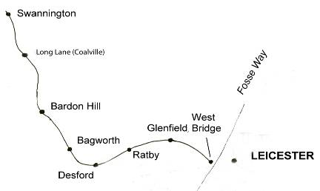
A Parliamentary Bill was drafted and submitted in 1829 and an Act authorising the railway followed in 1830. Construction started soon after and under Robert Stevenson's guidance the railway opened from Leicester to Bagworth on 17th July 1932, Bagworth to Bardon Hill followed in February 1833, Bardon Hill to Long Lane (Coalville) April 1833 and the final stretch from Long Lane to Swannington was opened in November 1833.
The opening of the railway meant that Leicestershire coal could be taken to Leicester more cheaply, in 1833 Leicestershire coal was selling at 10s a ton at Leicester undercutting the Nottinghamshire and Derbyshire price by 3s a ton. The reaction of the Nottinghamshire and Derbyshire coal owners was obvious, they needed to fight fire with fire and build their own railway. An infamous meeting at the Sun Inn at Eastwood 16th August 1832 ended with the decision to build what was then called the Midland Counties Railway. This railway through amalgamation, including the Leicester and Swannington, went on to become the Midland Railway with John Ellis, the ex chairman of the L&S as its chairman.
The Leicestershire and Swannington Railway, despite its modest size bristled with innovative features. The Charnwood Hills were cut through with the largest railway tunnel for the time at Glenfield, the 1 in 29 incline at Bagworth required not only a permanent pilot engine but also required that all passengers alight and walk up the incline. Finally at Swannington to bring the coal up from the low lying mines Stevenson built a rope incline with a new design of stationary engine to haul wagons.
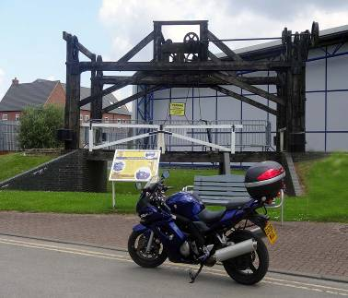
Although most of the line is now closed some of the lines heritage can still be seen. The Glenfield tunnel under the control of English Heritage is accessible some days during the year. Several brick ventilator shafts can be seen among the houses of the estate above the tunnel. A wooden lifting bridge, based on a design by Robert Stephenson, originally carrying a short branch over the Soar Navigation at West Bridge in Leicester, has been reconstructed next to the entrance of Snibston Discovery Park in Coalville.
At Swannington the remains of the engine house are clearly visible and the incline, now under the supervision of the Swannington Heritage Trust, has been opened as a footpath with information boards. The engine is now preserved at the NRM in York.
The central part of the line from Desford to Bardon Hill, on the outskirts of Coalville, is still used daily by the stone trains and can be observed from bridges, level crossings, and footpaths adjacent to Bardon Quarry works which brings me on nicely to my family connections to the railway.
As I mentioned at the top of piece my first actual involvement came when I started work at Coalville. It was only then that I came to discover that Coalville was where my great grandparents had met. After a little bit of research I was able to locate relatives still living in the Coalville area. My great-grandfather Edwin had moved in 1891 from a village called Pebworth near Stratford-upon-Avon to work for the L&S (now the Midland Railway) at Bardon Quarry. Whilst working at the quarry he met my great-grand-mother Harriet. They had an affair and she became pregnant, not too much of a problem you would think but unfortunately Harriet was married, but not to Edwin. Apparently under the auspices of the railway the couple exited stage left to Birmingham where Edwin continued working for the railway at New Street station. There is a happy ending in that they went on to have another child, a boy (my grandfather) and stayed together for the rest of their lives. I am still working at filling in many details of their life most importantly trying to find out what caused Edwin to leave the sleepy village of Pebworth and go to work at Bardon Hill? Any ideas welcome.
Richard Jones

The sleeper trip - two decades and counting
When the SMRS sleeper trip first started back in 1995, no-one thought it might still be going strong twenty years later. But so it has proved, and just to show that it was not only alive but prospering, an ambitious itinerary was planned for 2014. Very much back to our old haunts in the Scottish highlands, combining some of the best places previously visited with one or two new ones. We also continued the policy of two years ago, when wives/girlfriends/significant others were encouraged to participate in the latter stages.
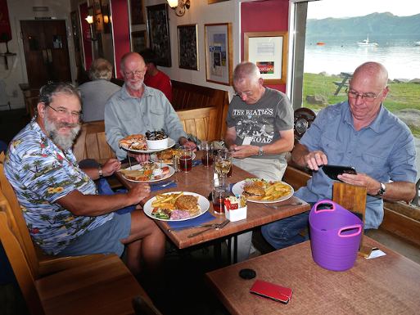
It turned out to be one of the most enjoyable trips we have had, the only disappointment being that Tony had to pull out at short notice. Rather unfair considering the amount of work he had put in to sorting out the train routes, timings and tickets, for our maximum convenience and minimum price. The bottle of Tobermory single malt was the least we could do by way of consolation, although I have to admit it was purchased from a Largs supermarket rather than from the distillery itself. Short of highjacking the Calmac ferry as it sailed round the east coast of Mull and directing it into Tobermory harbour, it was probably the best we could do.
The first stage to London was somewhat unusual by being via Bradford, for the simple reason that we could, and that it would make a change from the West Coast main line. Four of us departed by bus from Southport to Preston, where we diverted for the inevitable visit to the local Wetherspoons for second breakfast. A Grand Central train took us to Bradford, where we changed for the train to Kings Cross. A short walk to Euston produced the first (and fortunately only) hospitality failure - no food at the Doric Arch! However Jim’s encyclopaedic knowledge of real-ale watering holes was up to the task, and an effective substitute was soon located, the Bree Louise in nearby Cobourg St. There Malcolm joined us in time for an evening meal before we returned to the station to board the sleeper.
As we squeezed into the minimalist space in our cabins we reminded ourselves that soon all this would change, and over the next three or four years Serco would be spending a cool £100million (and not all of it from taxpayers) to upgrade the service. Ensuite facilities will certainly be welcome, also the brasserie-style club bar, whatever that is, but we will reserve judgement on the pod flatbeds. However in the meantime the charm of the existing service was undiminished and we availed ourselves of more hospitality in the lounge car as we progressed northwards.
As all experienced sleeper customers know, one of the crucial waypoints on the journey is the moment of waking up and peering around the window blind to establish a) if we are in the right section of the train after it split at Edinburgh, b) where precisely we are, c) whether we are on time and d) what the weather is like. The answers on this occasion were a) yes, b) approaching Ardlui, c) no, by a good half-hour, and d) cloudy but dry. Two-and-a-half out of four, but the crucial issue was the lack of punctuality, as we had a steam train to catch. Twice before we have had this problem, both cured by Scotrail’s provision of taxis to go train-chasing. Fortunately our steward had been on the customer service course and volunteered to phone ahead if necessary to book a vehicle to take us from Fort William to the Jacobite’s one and only stop at Glenfinnan. As it turned out, it was necessary, he did phone ahead and we did get to Glenfinnan in good time to claim our seats on the steam train, pulled by one of a pair of Black Fives rostered for the summer excursions along the West Highland Line.
At Mallaig we decided the priority was to call at that night’s B&B to deposit excess luggage. That done we explored the town in the relatively short time left, failing completely to find any cask beer, before boarding the Jacobite for the return journey. At Fort William one of Mr Riley’s Class 37s was spotted, going by the name of ’An Gearasden’, which according to a search engine beginning with G means ‘The Garrison’. Photos were taken for growler-gricers back home. We then changed trains for the final leg back to Mallaig on the service train. Even in mid-summer the town is not a hive of frenzied social activity in the evening, but we did find an excellent seafood restaurant, setting a trend which peaked later in the holiday. But more of that later.
Next morning (calm and sunny) we had spaces booked on the Knoydart ferry, which compensated for its small size by its high speed, taking us around the corner from Mallaig to the Knoydart peninsula in barely forty minutes. We failed spectacularly to convince the ticket-collector that we were locals, and thereby qualifying for a cheap rate, but the cost was fairly minimal anyway. Apparently she knew all the inhabitants of the village by sight, so we were on a loser from the start. The scenery was also spectacular, and remained so for the duration of our stay, aided by summer weather worthy of the name.
At Inverie pier we were met by the proprietor of our B&B, who took some of our party and all of our luggage by car, the rest of us yomping the mile or so along the one and only road, past the one and only bar and the one and only shop. As we learned later, Knoydart had been bought out a few years ago by the residents and has since prospered, with a significant increase in the number of those choosing to live in a remote part of Scotland accessible only by boat or by a rather long and rather arduous walk. There were quite a few cars in evidence, despite the lack of roads to drive them on, but being private land there was clearly no nonsense about road tax, MOTs or, in some cases at least, regular maintenance. The downside apparently was having to own your own bowser to store fuel delivered by boat, at a significant mark-up. Not to mention the need to buy (or mix your own) midge repellent in industrial quantities.
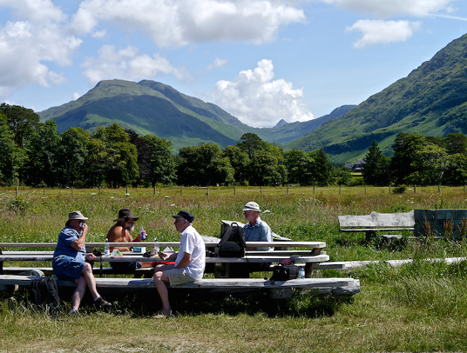
The B&B was a large purpose-built house owned by a couple who were on the point of retiring, and were therefore looking for a buyer for both home and business. For a fleeting moment we considered the possibilities of forming a consortium to make a bid, but regrettably reality kicked in almost immediately, and the idea faded as quickly as it had appeared. We consoled ourselves with a stroll around the extensive garden, which according to a sign at the entrance was for the benefit of the community rather than just house residents. Symptomatic of the way things were done here, perhaps. After a reviving cup of tea we set off for a walk down to the beach and along the river, guided by Jim, who had been that way a couple of years before, and was the prime mover in getting the location onto our itinerary. The beach was typical of the Western Highlands, white sand, a scenic location and hardly any other people. This one for some reason also sported a picnic table and an environmentally-friendly loo, complete with detailed instructions on its operation. We resisted the temptation and continued along the river, pausing to visit two local cemeteries on an estate previously owned by a notorious Nazi sympathiser and evictor of the Seven Men of Knyodart, who tried to settle on his land after WWII. That evening, after rest and recuperation at the B&B we dined at the Old Forge, famed for both food and beer, where Jim demonstrated his culinary prowess by demolishing a two-storey cake stand of assorted seafood, with nothing but the most simple of hand tools.
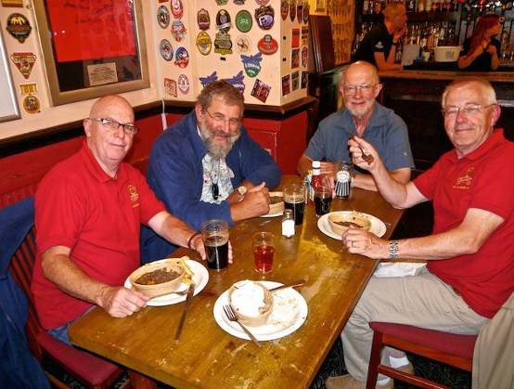
One would happily have stayed longer at such a peaceful and scenic location, but sleeper trips have their own discipline, and it was time to move on. Back to Mallaig on the ferry, this time with cloudier skies and slightly less smooth water, and then train to Oban. As is traditional, we confused our onboard train manager by alighting at Upper Tyndrum for the downhill walk to Lower Tyndrum, instead of the more sensible option of walking five yards across the platform at Crianlarich. On the way we stopped off for lunch at convenient roadside cafe. By the time we arrived in Oban the rain had set in, and it was a rather damp arrival at the next B&B. And there was no resting in a warm dry lounge, as a pair of significantly better other halves was due to arrive on the evening train from Glasgow. So it was back to the station to await their arrival, with entertainment provided by a local school pipe band, doing their bit for social cohesion in the square outside. Once all were reunited we again made use of an adjacent Wetherspoons before retiring for the night.
Next day we were up early for the ferry to Barra, a six-hour crossing via Coll and Tiree. Initially all was smooth and serene as we sailed around Mull, but in the open water beyond the swell increased and the passenger lounges went quiet as their occupants concentrated on keeping well. Some entertainment was provided at the island stop-offs, particularly by those not used to reversing down a long and not particularly wide pier to get their vehicle onboard. By mid-afternoon we were in the shelter of Castlebay harbour, with a pair of fine-looking schooners for company. The scenery, which we knew from past experience was of considerable quality, had gone shy on us and remained hidden behind copious cloud formations.
Nothing daunted we split into three groups to search out our accommodations for the next two nights, and then reunited at the Castlebay Bar for pre-dinner aperitifs. We were not surprised to find a dearth of cask ale, but there were a number of bottles with ‘Drink Me’ writ large on the label, in a number of different scripts. What was surprising was the identity of the Keeper of the Darts, a trained-to-the-edge-of-canine-reason collie, who insisted we all took a turn at her dartboard, with no taking no for an answer. Indeed there were several of us who were convinced of her ability not only to marshall a continuous stream of arrow-wielders but also to tap out their score with a graceful blink-and-you’ll-miss-it flick of the left paw. But perhaps it was just the effect of the beer. Some gentle interrogation of local residents confirmed our suspicions that the curry-and-seafood (separate plates) restaurant on the quayside was the best place to eat, and so it proved. The scenery gradually relented and formed a fine backdrop to the gastronomic experience, such that we came back the next night and did it all again.
The weather continued to improve overnight, and Friday dawned fine and clear. The intention was to start with a short boat trip across the bay to the castle, but for reasons which the guilty will carry to their graves only five actually embarked, the other two doing a fine job of pretending they didn’t really want to go anyway. During coffee and souvenirs at a small cafe overlooking the harbour, a yacht departed its moorings to the sound of a lone piper on board. A lady watching from the shore advised that this was one of the finest pipers in Scotland (we wouldn’t have known) on his way to a festival on a nearby island. Apparently her husband was going with him, which seemed to be quite in order as far as she was concerned.
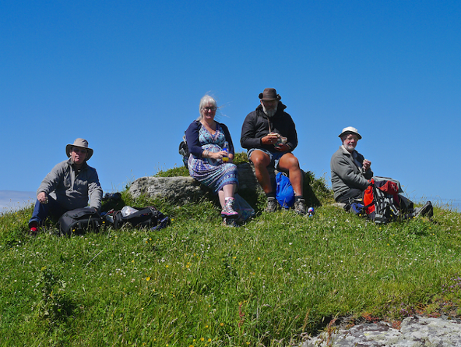
The Parkinsons then decided to explore the island with the help of the local buses, the island tour company being fully booked that day. The rest of us, after a diversion to buy lunch materials, took the bus in the opposite direction, across a causeway to the small but beautifully-sculpted island of Vatasay. At the island’s one and only village we alighted, noted carefully the time of the return service, and set off on a circular walk to a hillock which the map described as an iron-age hill fort. No evidence of habitation remained, but the scenery more than compensated for its absence, with more white beaches, bays, headlands and a fine view back across the water to Castlebay. We also passed the ruin of the local headman’s house, a victim along with many others of Highland clearances. The return leg required some careful navigation to avoid some rather squelchy vegetation but we returned safely and only slightly muddy to await the bus, which was almost on time. Then back to the seafood-and-curry house, where the proprietor rewarded us for our repeat custom with a fine rainbow, not to mention the stately arrival of the ferry from Oban, in calmer waters this time.
Next morning saw the Fords break away from the main pack to continue their stay on Barra, moving upmarket to the Isle of Barra Beach Hotel, allegedly the most westerly of its type in Britain. The rest of us took a taxi to Barra International Airport to await the arrival of the Glasgow plane. This duly arrived, and landed on the beach with a lack of fuss which suggested that at least one of the pilots had done it a fair few times before. Apparently the time and tide were a little against us, so we were gently encouraged not to dally whilst boarding, and we took off with the wheels wet with the incoming water. The flight took us over not only Coll and Tiree again but also Skye, and several sea-lochs sparkling in the sunshine, looking for all the world as it they didn’t contain nuclear-armed submarines.
All too soon we were flying over the built-up areas around the Clyde, aiming for a point just north of Paisley, which fortunately coincided with Glasgow airport. With very little delay we disembarked, retrieved our luggage and caught a bus for Gilmour St station, one of four serving Paisley. A train then took us along the scenic Ayrshire Coast Line to Largs, our destination for the night. Here the summer holidays were in full swing, with weather to match, and the town was doing what it was clearly set up to do, namely entertain large numbers of Glaswegians intent on having a (fairly genteel) good time. The ferry to Cumbrae was in much demand, to the extent that what appeared to be a reserve ship had been pressed into service to cope with the crowds. What the particular attractions were of the island we were not sure, and our taxi-driver professed some bemusement likewise.
Ice-creams were clearly called for, and were duly purchased from an Italian establishment with a length of queue which suggested the quality of either their produce or their publicity was above average. Our stringent testing confirmed that it was certainly not lacking in at least the first of these, so much so that we returned that evening for a pizza dinner. The B&B that night was also of high quality, overseen by well-organised and experienced proprietors.
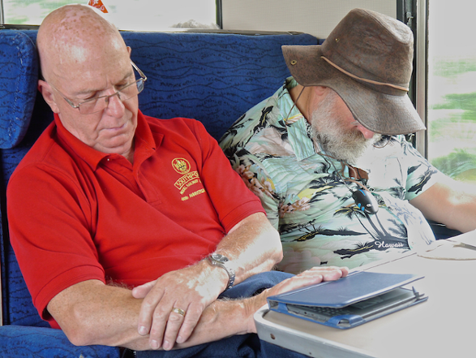
Our last day dawned, and we returned by train to Glasgow, where Malcolm left us to follow his own altered route home, following exhaustive and exhausting negotiations with the customer services person at Largs station, who clearly knew just whose service they were working for. For
Our last day dawned, and we returned by train to Glasgow, where Malcolm left us to follow his own altered route home, following exhaustive and exhausting negotiations with the customer services person at Largs station, who clearly knew just whose service they were working for. For the rest of us it was a busy but speedy train to Preston, just in time to miss the Southport bus. However there’s always another one behind, for he who cares to wait half an hour.

***********************

Features
Continuing with Allan’s series of papers on electrical matters. If you wish to see the preceding articles, they are all to be found on www.eastbank.org.uk .

Short Circuits No. 15 - More on Diodes.
As mentioned in previous articles, diodes are really useful devices in model railway control circuits. Fundamentally, a diode is a solid state device that passes current in one direction only with only a very slight voltage drop. In the reverse direction a very high resistance is presented so no current flows. So what can we use them for?
Do you have dead end sidings on your layout and have you ever driven a train off the end of the siding, crashing into the buffers or even worse, crashing through the buffers and off the layout and onto the floor thus ending in financial tragedy. If the answer to that question is yes then this is for you.
By having a single rail gap bridged by a diode correctly connected, an automatic dead section of a couple of feet may be inserted. Once the loco passes the gap, current is disconnected and the loco stops, somewhat abruptly but that is preferential to it ending up on the floor. To retrieve the loco from the siding simply reverse the line controller and the loco can be reversed out. This only works of course if the loco is at its traditional place at the front of the train.
Diodes grouped in fours can be used a rectifier, that is to convert from Alternating Current AC to Direct Current DC. Units are available with the four diodes encased in plastic and are much more convenient to use. The output from this rectifier is an unsmoothed DC at about 14 volts at position A. If a capacitor is connected as shown, this will smooth out the output and also increase the output voltage due to the capacitor charging up to the peak value of the AC supply at position B. As always, make sure all the components are operated within their stated tolerances.
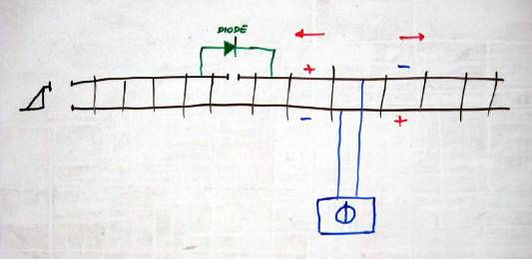
Automatic stop at the end of a siding
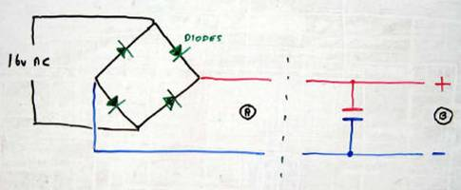
Diodes used as a rectifier.

Single diodes are also useful if headlights on locos are required to operate in one direction only. Just wire a diode in series with the lamp. If using LED lights make sure that reverse voltages are not connected across them. Use a regular diode in series with the LED.
Self flashing LED lights are available. If further regular LED lights are connected in series with one then all the LED lights in the circuit will flash, not just the flashing one. The uses are infinite.

