 | Southport Model Railway Society  Newsletter  No 33: July 2014 Editor- Ian Shulver ( i.shulver@btinternet.com )

Last month I indicated that I was passing on the mantle of newsletter editor to Peter Mills. However, he is unable to take over at the moment so for the time being I will continue to bring you this document. As you will see, it is a much shorter newsletter than normal, but a regular short one is preferable to one that is irregular but more substantial.

Ian - Editor

Chairman’s notes:
By the time you read this the 20th Sleeper Trip will be well under way, returning to the rugged beautiful mountain scenery of Scotland. Because it is a milestone anniversary we thought it would be a good excuse to revisit some of our favourite places from past visits, so amongst other things we will be riding the Jacobite and by contrast flying to Glasgow from Barra taking off from the unusual white sandy beach runway. Hopefully this may form the basis of subject matter for a potential monthly talk.
However you may have some ideas of your own for a presentation. So this is addressed not necessarily to our stalwart band of regular presenters but to you. Don't forget there are many around who can give help and advice in preparation. Have a think about a railway subject then come and talk with Ian (S) or myself to help get you started. By the way I'll have a go if you will.

Frank
***********************

Monthly talks:
The June talk was given by Richard Jones on the Leicester-Swannington Railway. It was essentially a two-parter; the first part describing the formation of the railway and its subsequent history, followed by Richard talking about how he is associated with it. Apparently Richard was first acquainted with the line once he left college where his first place of work was at the North West Leicestershire College in Coalville, which was almost at the end of the line. When he mentioned to his mother that he was going to work there, she commented that his great grandfather, although originating in Warwickshire, worked at Bardon Hill Quarry where he met his future 'wife' before then decamping to Birmingham in circumstance that are not all too clear. Richard's tale was both amusing, informative and provoked some considerable discussion. Many thanks to Richard for giving this history and mystery talk.
The next talk will be on Tuesday 15th July and will be given by Allan Trotter. This will be held at the Clubrooms and will be aslide show titled “ Ships on the Clyde, the English Channel, and more”.
In August (12th) Jim Ford has offered to give all those interested some instruction in the art of firing and driving radio controlled 16.5mm steam locos. This will be at an earlier time of 6.30 in order to make best use of daylight hours. It will be followed by food when the light fades.
***********************

Layout reports
Portland Street - Upper & Lower (Tony Kuivala). Currently out of commission until the room has been redecorated.
Monsal Dale (Ian Shulver) - Breaking news is that Monsal Dale has been invited to the Warley Show in 2016. More details about this in due course
On the summer solstice weekend, Monsal Dale was one of the attractions at the Woodvale Rally in Victoria Park. Setting up on Friday morning was simplicity itself - we had virtually the whole marquee to ourselves so we could spread out and with help from Tony and John, the layout was erected and operational in no time at all. Over the weekend the layout, locomotives and stock performed almost flawlessly albeit with a few unplanned uncouplings and the odd mishap in the fiddleyard. The only problem, if that was what it could be called, was the weather. It was gloriously sunny making conditions inside the tent rather hot and humid, but fortunately the layout and operators took it all in their stride. The weekend did highlight a few improvements that could be made to provide for more operational flexibility. The single slip (typical Midland practice) in Monsal Station will be replaced with a double slip to enable the down loop to be utilised without the necessity to clog up the up-line. In the fiddle yard extra points will be laid so that the central crossover loop can be accessed from both up and down lines at either end. This will enable the Blue Pullman to be stabled there and be able to operate both to and from London. Finally, some minor structural modifications will be made to the control panel to allow it to be hung onto the ends of the layout to give the operators abetter view of what is happening.
Talisker Glen. As with Portland Street, Talisker Glen is out of commission until the room has been redecorated. Once completed work on the layout will recommence.
***********************
2014 Exhibition Continues to fall into place.

***********************

Forthcoming events
The programme for the next few months is as follows:
June 7-8 Wigan exhibition
July 15 Ships on the Clyde, the English Channel, and more - Allan Trotter.
August 12 Learn to drive a radio controlled 16.5 steam train – Jim Ford
Nov 8-9 SMRS Annual Exhibition
***********************
57a Redecoration
Internal: Portland Street has now been moved to allow access to the end wall. Once the weather has cooled a little, we can start to strip the wall and assess what needs to be done.
External: Nothing further to report
***********************
Member’s news:
The Society was well represented at the Woodvale Rally in June, with layouts from Mike Sharples (Flossil Quay), Terry Tasker (Jacksonville Yard), Derek Pratt (Walmer Bridge) and Monsal Dale. The Club display board was also in attendance. Many thanks to all those who put in an appearance and helped on the layouts.

Seen in a book “ Leaves on the Line – letters on trains to The Daily Telegraph”, edited by Gavin Fuller.
14 April 1950 - GROWN-UP'S REBUKE
SIR - When will the Model Railway's Club exhibition be given its due, and cease to be referred to always as a children's paradise?
The exhibition is not designed for children, and I wonder that your reporter can be surprised at the greater number of adults attending. Nor are the exhibits toys - they are beautiful scale models, superb examples of craftsmanship.
As a railway modeller I know I shall enlist the support of all railway modellers in voicing this, our perennial, source of annoyance.
Peter A. Spring
Bramhall, Cheshire

Although seemingly to specifically be concerned with the Model Railway Club (of great Britain) and its London exhibition, I would suggest that in the public's eyes, their view of model railways, and in particular exhibitions, has not changed in over 64 years.

***********************

Features

Continuing with Allan’s series of papers on electrical matters. If you wish to see the preceding articles, they are all to be found on www.eastbank.org.uk .

Short Circuits No. 13 - CD or not CD, that is the question.
Whilst it is perfectly adequate to power your solenoid operated points directly from a 12 volt DC or 16 volt AC supply, there are a couple of limitations that show up. The supply will only usually change one point at a time and if the lever switch or push button is held operated for any length of time there is the problem of overheating, much melting of plastic and windings, all accompanied by an acrid burning smell. There must be a better way of doing it. There is. It is called a Capacitor Discharge Unit or CD Unit.
A good analogy to a model railway capacitor discharge unit is the lavatory cistern. Here a small bore pipe delivers water at a limited rate of flow and fills or charges up the cistern. On operation of the flush mechanism, a large amount of water discharges rapidly, executing its primary function.
For the simplest form of model railway CD unit all that is required is a capacitor and a resistor. When power is connected the capacitor charges via the resistor up to the peak value, not the average value, of the supply, usually about 22 volts. On operation of a point button or switch the energy stored in the capacitor operates the solenoid. If the button is held operated, the current through the solenoid is limited by the value of the resistor thus preventing the melting solenoid syndrome. The advantage of using an AC supply is the higher peak voltage as the energy stored in a capacitor is proportional to its capacitance but is proportional to the square of the voltage. With this simple unit there is one downside however, because of the resistor, the unit will take time to recharge, just like the water cistern.
The solution to much reducing the time delay is to venture into solid state technology using a power transistor. The transistor is used as a switch to disconnect the output if any buttons are held operated. On release of the button the capacitor charges directly from the supply and is ready for use very quickly. The green LED indicated power is on and the red LED indicates a button held in the operating position. On disconnection of the power supply the unit will automatically self discharge saving you the treat of getting a surprise bite from the capacitor. Commercial purchased units may be limited in the number of points that can be changed simultaneously therefore a custom built version can be made to provide extra energy.
Buying the few components is not expensive and remember you only have to build one of them for your whole layout.
Do you want to change even more points simultaneously? That's for next time.
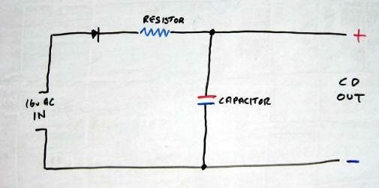
Simple Capacitor Discharge Unit
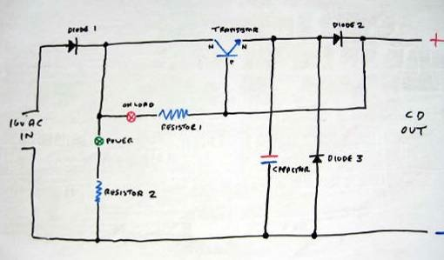
Fast Recovery Capacitor Discharge Unit

