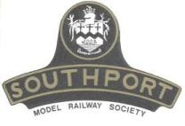 | Southport Model Railway Society  Newsletter  No 25: October 2013 Editor- Ian Shulver ( i.shulver@btinternet.com )

Editorial –

We are now starting our third year of this illustrious newsletter. Although marginally shorter than usual, the content more than makes up for this. The slightly later issue date is the result of recovery time required after our hugely successful exhibition (see Tony’s report) but this was all to the good since it has enabled me to include an amusing (and all too true) note from Sammi (one of our member’s wife).

Chairman’s notes

To round off our celebratory 40th Anniversary year we have seen it to its conclusion with a well received, successful and popular as ever Exhibition made particularly possible by some very impressive layouts.
Although it is debateable whether the sunshine weather was responsible for the slightly reduced attendance figures from last year, it could also be argued this was only one of the reasons for the many happy faces I saw over the two days helped more of course by what they had seen and experienced at the show.

Once again I wish to thank all members, spouses, friends and all others who contributed their time and effort to make this another successful and enjoyable exhibition.

Frank
***********************

Monthly talks:
Our September talk/photo session was given by Peter Clare on German Railways – a slightly lower than normal turnout perhaps because the subject was not everyone’s cup of tea. Irrespective of that Peter, showed a series of excellent photographs taken during a couple of holidays he had in Germany in 2010. Our thanks to Paul for hosting this event.
The October talk will be given by Peter Mills on Thursday 31st October. PLEASE NOTE THIS IS ON A THURSDAY IN ORDER TO FIT IN WITH PETER’S WORK SCHEDULE.
The subject of Peter’s talk is My modelling life. This talk will focus on how he started in model railways, what inspired him to want to make the leap from toy train set to model railways, the attraction of steam locomotives and which ones he liked and how he became interested in other area of railways. Finally he will talk about his current model railway project and the inspiration behind it. It will be held at Tony’s (73 Sefton St).
***********************

Layout reports
Portland Street - Upper & Lower (Tony Kuivala) - Both Layouts are operational and in constant use. The outstanding work on Portland Lower remains deferred. Controls for Portland Upper are now fully operational from inside the well in Layout. More buildings have been acquired.
IMPORTANT NOTICE FOR ALL USERS OF PORTLAND UPPER & LOWER – Once the operating session has concluded, you MUST switch of the mains at the board nearest the door. This is to prevent serious damage to the transformer, controller and to minimise the risk of fire.
Monsal Dale (Ian Shulver) – No report this month.
Talisker Glen (Peter Mills) - September saw the exchange sidings finally finished after our electrical guru spotted my mistakes, which meant redoing some track work. It necessitated replacing some fish plates from metal to plastic and some other minor bits and bobs. Obviously I paid no attention to his talks!
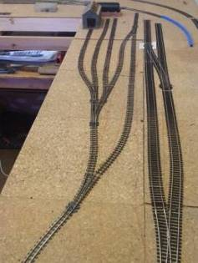
The photograph shows the finished track plan, It is exactly what we were after, giving operational flexibility between the gauges.
The outer track will be finished and the electrical planning phase started within the next three weeks. It is important to take a little time over electrical operation, but Planning what you want the layout to do now, before holes are drilled and wire fed through and scenery put on will pay dividends and make sure the layout will demonstrate what you set out to achieve.
***********************
Exhibitions (Tony Kuivala).
2013 Exhibition. After an eventful September everything was in place and all went according to Plan. As a Plan is only a photograph at a given time the numbers and £s take a while to become reality. Initial indications are that we held our admission numbers at 2012’s levels which were up on 2011. Secondary spends in café, Club Stand and most of traders suffered in the current climate but we have not suffered anywhere near as badly as has been reported back from other exhibitions. To mark our dual 40th Anniversaries of SMRS and Exhibition we brought in a larger number of significant sized layouts which from feedback so far was very positively received and probably accounts for our patronage holding up even though we had brilliant weather which historically has diluted numbers.
Liverpool Lime Street was judged The Best Layout, Great Western Railway for Best Scenics, Kirby Stephen West for Best Rolling Stock and New Bridge Junction was Best N Gauge. Derek Pratt again won the Club Competition – Layout in a Box – with a Mine display which was five layouts in one. We will be reviewing the handicap arrangements for 2014.

2014 Exhibition. This moves to the weekend of 8th & 9th November. Nineteen layouts are booked so far. Three of our traders offer apologies as they have long standing commitments elsewhere. When we return to our normal September they will be rejoining us. In meantime I will be on lookout for one or two “specialist” traders and an unusual one.
***********************

Forthcoming events
The programme for the next few months is as follows:
October 4 Exhibition feedback meeting.
October 31 My modelling life (Peter Mills).
November How to use Paverpol (Shirley Tasker).
December Rails in the North (Jim Ford).
***********************

News from members:-
Life as a Railway Widow
Married life always starts out the same way – it’s all romance and roses, kissing and cuddles – barely able to be parted from our beloved for more than a few desperate moments. However, for some of us (and we have yet to decide whether we are the less, or more fortunate) this blissful honeymoon period makes way for something else. This something sneaks up on us like a cat on an unsuspecting sparrow. It begins innocently enough, hints being dropped randomly into conversation, magazines left surreptitiously on the coffee table, vague references to this event or that ... their expertly veiled, hidden obsession delicately prodding at your conscience like a child picking at a scab.
Pick.... Pick..... Pick....
Until... before you know it the scab has gone and the full-force of this unstoppable, all-consuming passion has lurched out at you and grabbed you by the throat. You know just by the look on their face that they’ve gone over to the dark side – the lights are on but the brain has wandered off. Wandered to a place where it can calculate the rake needed to scale a miniature mountain, a place where getting steamy has more to do with cogs and wheels than it does skin and satin, a place where shunting, fiddle yards, weathering and coal have oozed into the space previously reserved for emotion, attraction, amore and other such ephemeral things.
I’m afraid that from there on, the prognosis is not good - once this sickness takes hold there is no cure, no respite and no remission. All you can do is fling yourself martyr-like onto the altar of their new religion – completely, whole-heartedly and without regret .. and jolly-well join in! Before you know it you’ll find yourself chasing the 15-Guinnea Special across the country, or absent-mindedly designing a loco-shed on your coffee break, or maybe volunteering at a heritage railway on your day off ... and having a chuffin’ marvellous time together in the process!
So, mourn for me not – because the Railway Widow lives a life re-born, a life of diesel, steam, companionship and an eternal shared passion. Toot toot!
Sammi Rudge

***********************

Features

Short Circuits No. 5 - What's the Point.
Most people today that are interested in model railways started out as a child with the humble train set. Just which manufactures' train set you received depended on the era when you started out and of course the finances available.
The first readily available 00 scale train sets were produced by Hornby Dublo from 1938 onwards but this was a three rail system. The Hornby Dublo three rail range was not fully developed until the late 1940's due to Adolf interfering with the production schedule. The first readily available and mass marketed two rail system was produced by Tri-ang Railways around 1951. It took Hornby Dublo until 1958 to introduce a two rail system. Here endeth the history sermon.
Once you have your trains running around an oval track, the first additions usually acquired is more track and some points. With the Tri-ang system there was only one rule concerning where the power feed was connected to the track. To ensure that either track was live depending on the setting of the point the feed must be at the toe (narrow) end of the point. All points are self isolating resulting in the point acting just like a change over switch.
If points are to be arranged with the power being fed from the heel of the point such as in a goods yard, all that is required is a single permanent bridging wire to maintain the fully operation self isolating facility. Rail gapping and additional power feeds are not necessary. Everything about two rail track layouts remained nice and simple until Hornby Dublo introduced their own version of two rail.
The fundamental difference between Tri-ang and Dublo two rail track was the points. Tri-ang used self isolating dead frog points and Dublo used self isolating live frog points. As anyone who has built a Dublo two rail layout will know, Dublo two rail track geometry is very convoluted and with it is the added complication of essential double and single rail gapping even for an oval with just one single point. Not a simple matter by any means. Dublo produced copious amounts of instruction concerning these complications but in reality, who reads instructions, especially on Christmas day?
Don't be put off by live frog points. They permit an improved quality of running and also better reliability. Using, wiring and gapping live frog points is not complicated but the rules must be adhered to. That's for next time.
Live or Electrofrog Point. Gap essential.
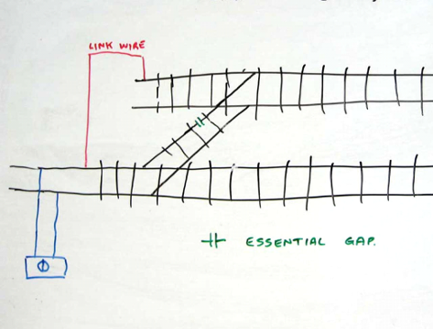
Dead or Insulfrog Point. Gap not required.
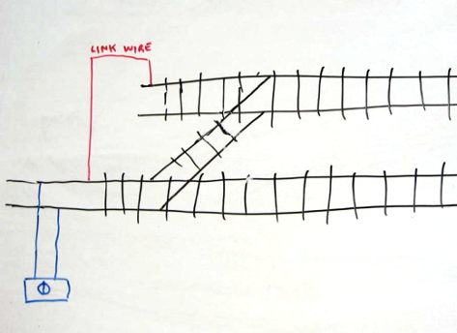
Allan Trotter

Scale and Gauge.
The term 00/H0 is often mentioned in model railway circles, it is often misused but what does it actually mean?
First of all, it is impossible for a model to be both scales at the same time as these are two distinctly different scales. Although both run on the same 16.5 mm gauge of track, 00 is of 4 mm/foot scale and H0 is of 3.5 mm/foot scale.
Then there comes the question of loading gauge. As we are all aware, British mainline locomotives and rolling stock can be run almost anywhere in the world that uses standard gauge track but the converse is certainly not true. As far as the United States of America and Canada are concerned, their trains do dun on standard gauge track but their loading gauge profile is considerably greater than that in Britain.
The illustration shows two models. One is a British Class 33 locomotive and the other is a North American GP38-2 locomotive. Remember both models are to the same correct H0 scale. As always a picture is worth a thousand words, well one hundred and eighty six words anyway.

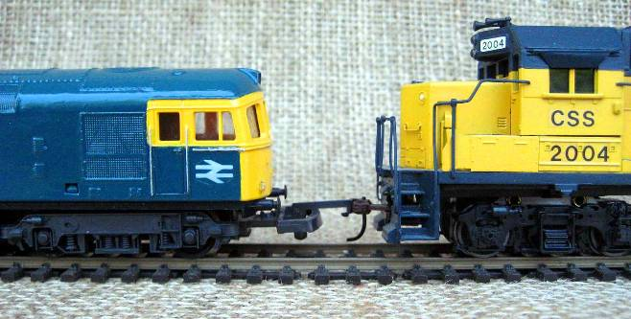
Allan Trotter

DCC without wires
On might be forgiven for thinking that the name 'Timpdon' refers to a children's TV programme, set in a cosy village of the same name, where all the people are unbearably good-natured and all the animals are unrealistically well-behaved. For all I know this may be the case, but it is also the name of a supplier of radio-control units. They are based in Altrincham and specialise in controls for garden railways.
So far, so ordinary. What makes them different is mainly twofold. Firstly the equipment was developed as a means to control locomotives on a particular railway, namely the portable and highly-popular 16mm layout 'Timpdon Lake', a veteran of exhibitions in the North-West (and further afield) for more than ten years. The system was therefore purpose-designed for the job. Secondly the transmitters operate at 433MHz, which is a good few kilocycles below the current crop of 2.4GHz units almost universally used to control trains, boats and planes, and cars. As to why this is much better I hesitate to say, mainly because I don't really know. I can however point you in the direction of a Technical Note, should you really wish to discover for yourself.
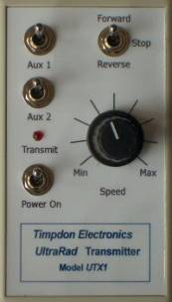
However, there are some advantages apparent even to the technically impoverished. The transmitter is really small and light, about the size of a mid-range smartphone, but a bit thicker. It can easily be held and operated by one hand, leaving the other free to twiddle gas regulators, re-rail misbehaving stock or hold a modestly-sized plate of comestibles. Speed is controlled by a rotary knob and direction by a simple switch. Experience so far is that locos seem more controllable and responsive to the thumb of command than is normally achieved with conventional radio control. There are auxiliary switches for lights, horns or whistles, and one model in the range can operate up to ten different locos by rotating a selector. Which means you only have one transmitter to spill tea over, drop in the pond or leave out in the rain. Or in my case, leave at home.
The multi-channel transmitter also creates a significant operational advantage, in that it is much easier for one person to control two or more locos at (more or less) the same time. A train can be parked in a passing loop and control changed to another which then drives past it. The sort of thing that smaller-scale train drivers have been doing since Frank Hornby was a lad, but is fairly rare in garden scales. It is also possible to specify that a train will continue running once control has been changed to another, the default being that it comes to a halt after ten seconds. Most operators using conventional equipment only drive one train at a time, no doubt because holding two bulky transmitters simultaneously not only strains the wrists but also leaves no spare hand for the G&T.
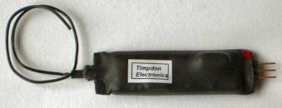
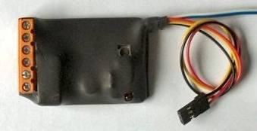
Each loco carries a small radio receiver, which is wired to a controller unit. For live-steam locos this operates the servos for the regulator and reverser. As not all servos are the same, calibration facilities are provided for no less than ten different parameters. For battery-powered locos, the controller directly governs the speed and direction. Third-party electronic speed controllers are also catered for, using a special interface unit. Other modules are available to control points and signals.
If there is one downside, it's not a particularly cheap system, although having the multi-loco transmitter option is quite a money-saver. It seems a straight choice between something mass-produced in China for model aircraft and a well-engineered UK-made specialist model railway product. For many there is no argument, preferring to spend their limited resources on rolling stock and track rather than on smartypants controllers. However this particular modeller is gradually (and some would say at his age, about time) realising that quality is sometimes worth paying a bit more for.
Derek Pratt
***********************

