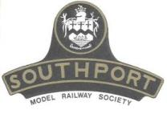 | Southport Model Railway Society  Newsletter  No 24: September 2013 Editor- Ian Shulver ( i.shulver@btinternet.com )

Editorial – Believe it or not, our newsletter has now been going foe two years. I have tried to maintain it at four pages with a mix of what is happening at the Club, news from members as well as feature articles. This has not always been easy with some months being a real struggle to find sufficient copy. I know I keep pushing this, but I would really like more of you to contribute, after all it is your Club and your newsletter - however, my thanks to those who have sent in article (keep them coming) Anything with a railway or railway modelling will do – e-mail or handwritten as long as the content is not scurrilous.
On another note, this month sees our 40th annual exhibition and the theme of this year’s competition is “A layout in a box”. I do hope that everyone has already something to enter, if not you still have three weeks in which to produce an exhibit. Tony has intimated to me that he can make space for a layout from each member (we have 20+ members so personally I would like to see 20+ entries).
Chairman’s notes
As you read this I am, for my sins, still enjoying remnants of a well deserved (well I think so) holiday. After all I have been working extremely hard at completing or at least attempting to complete the garden railway circuit of Chez Chairman, toiling in uncomplaining fashion in what has been a continued and generous amount of summer sunshine. A dirty job but................ Our former Chairman has been involved in a similar quest but I fear he has passed the finishing post.
Although it seems as if summer has just started it is only a few weeks before our Railway Show which in turn heralds the arrival of Autumn. I am of course looking forward to what promises to be a spectacular 40th Anniversary edition. It reminds me too that I need do more work on my competition entry, left on the back burner while I was exploiting the opportunity for garden modelling. I have always enjoyed this aspect of the show and the challenge it brings, not only to my modelling skills but also my own time management discipline.
Last years show was, I believe, the best so far. I think though, bearing in mind the line up Tony has booked, that we shall excel this year especially given the untiring help and support that we have come to know as the norm from all of you for which I say thank you in advance.
Frank
***********************
Monthly talks:
Tony and Jim gave a talk at Southport Model Engineers on Wednesday 14th August about our Club History – mainly anecdotes about the various buildings, exhibitions and past and present members. A good turnout from the SME who we hoped enjoyed it
The next talk/photo session will be given by Peter Clare on German Railways – not everyone’s cup of tea, but promises to be an interesting excursion overseas!! This will be held on 10th September at Paul’s (Flat 1, 79 Avondale Rd North). Please note that if you wish to partake in the food then you need to e-mail Tony by Sunday 8th September, otherwise you will end the evening hungry.
***********************
Layout reports
Portland Street - Upper & Lower (Tony Kuivala) - As both Layouts are operational and in constant use it is a frustration that work on Portland Lower keeps having a regular deferment whilst slow progress is under way on Portland Upper. Onwards and upwards……
IMPORTANT NOTICE FOR ALL USERS OF PORTLAND UPPER & LOWER – Once the operating session has concluded, you MUST switch of the mains at the board nearest the door. This is to prevent serious damage to the transformer, controller and to minimise the risk of fire.
Monsal Dale (Ian Shulver) – had an outing to the Leyland exhibition in mid August. A small, but nice, show with some excellent layouts. More trouble occurred with Monsal Dale but this time on the down line through the station where a short had appeared (probably in the single slip). The exact cause could not be tracked down under the show conditions and this prevented running on that particular track (we did place a static coal train waiting at the home signal to add interest). It is not clear what the problem was – we did catch the wiring loom on the way into the exhibition hall but there were no obvious loose or crossing wires. A careful examination in the ‘peace’ of the clubrooms and some ‘remaking’ of soldered joints was undertaken which appeared to have cured the problem (fingers crossed).
Talisker Glen. There hasn't been a great deal of activity on the layout in the last four weeks, mainly due to the weather and a busy period on the Ratty for me. In the winter we suffered because of lack of heat, ironically now, there has been too much heat upstairs. The activity that has taken place has been in the exchange siding area. A couple of items have were overlooked have been ordered to help finish this area off next week.
Work on the electrics will start in the third week in September with our aim of completing that by the end of October.
Work on the main distillery building is also progressing at a reasonable rate.
***********************
2013 Exhibition (Tony Kuivala).
We have entered final phase of preparations where it all gets hectic with last minute changes and the unexpected little issues that arise. What remains of my hair is grey anyway and if necessary I know of a darkened room to hide away in.
Updated listings of societies and traders will be released shortly onto our website and sundry other places. George Nutter sends apologies for his absence in 2013. Friends of Meols Cop Station are joining us for the first time. We have two new traders – Alan Beattie from St Helens with “Signs whilst you wait” and Direct Train Spares from Burnley. There are no changes (yet!) on layouts. I think we might have found a winning formula with Allan Trotter’s offer that we (he, that is) will offer a service to transfer 35mm colour slides to a digital format. As no fee will be charged there will be a limit of four slides.
There is increasing interest that Merseyside Transport Trust will be running a special Classical Bus service (no fares charged) between Ainsdale Station and our Exhibition. We are considering increasing the service frequency. Timetable etc will be published in mid September.
***********************
Forthcoming events
The programme for the next few months is as follows:
September 10 German Railways (Peter Clare)
Sept 28-29 40th Exhibition
October Title to be declared (Peter Mills)
November How to use Paverpol (Shirley Tasker)
December Rails in the North (Jim Ford)
***********************

News from members:-
I hope that the following is ‘tongue in cheek’, or perhaps not…or maybe a combination. Ed

Charter for Coarse Scale Modellers - The Ten Commandments
1. Since the model railway hobby consists mainly of immature old men playing with toy trains, descriptions such as fine scale modelling or creative artistic craftsmanship in miniature are simply in denial of the reality of their situation.
2. All locomotives and rolling stock must be equipped with full size, bogie mounted, Tri-ang Railways compliant Mk. III metal couplings on both ends. All locomotives and rolling stock must be able to operate over and couple up automatically on first radius reverse curves. All other forms of couplings are unreliable, especially at full speed and in reverse.
3. Tri-ang Super 4, Code 150 steel track is the track of preference, thus taking full advantage of the superior performance of locomotives fitted with Magnadhesion. All rolling stock is to be fitted with wheels that have wide treads and deep flanges to ensure superior tracking ability, especially at high speed on first radius curves.
4. The power controller dial must be able to go up to 11. You never know when that extra turn of speed will be found necessary. Aficionados of Spinal Tap will understand.
5. Fine detail on layouts, locomotives and rolling stock is completely unnecessary as layouts will be viewed from a sensible distance and trains are to be kept moving at an enhanced speed, preferably setting 11 on the controller.
6. Microsoft products are not to be used on layouts. Dodgy software and temperamental computers are an unfortunate necessity in real life but not for a subject as serious as toy trains.
7. No Digital Command Control system is to be considered for use on a layout unless the layout is to be operated entirely by ladies. Men simply do not have the ability to multitask.
8. No type of advanced technology that cannot be repaired quickly in an exhibition environment is to be installed on a layout. Keep it simple, stupid.
9. Self nominated, so called prominent modellers and conceited fine scale zealots must not be permitted to be in contact with the public at an exhibition. Layout operation is to be undertaken entirely by presenters with enthusiasm and an aspiration to enjoy themselves and also to entertain and converse with their paying public audience.
10. If you do not agree with any or even all of the listed commandments, that's not a problem. Unlike serious fine scale railway modellers, we absolutely respect the right and the privilege of others to express an opinion differing from ours.
11. Like the controller, the list also goes up to 11. Remember, trainsets and model railways are supposed to be fun.
© Eastbank MMX

Mike Sharples has provided some information and photographs of a Pechot-Bourden 009 kit that he has recently completed.
Péchot-Bourdon locomotive
A recent project was a Chris Ward Pechot-Bourden 009 loco kit with a Kato shorty chassis.
The Péchot-Bourdon locomotive was the final development of the Fairlie type. The Péchot-Bourdon was developed by Captain Péchot of the French artillery to operate on 600 mm (1 ft 11 5⁄8 in) gauge railways associated with field artillery and fortresses. The design was chosen with the belief that if one boiler or set of valve gear was damaged by enemy fire, the loco could continue to operate. The primary difference between a Fairlie and the Péchot-Bourdon is that the latter only had one steam dome. Only one design was constructed, a 0-4-4-0. About fifty examples were constructed in 1906, and a further 280 were constructed during World War I, some by the American Baldwin Locomotive Works.
Two examples are preserved, one in Dresden Transport Museum, Germany, and one in Serbia at Pozega Railway Museum.
Fig 1 The double ended body
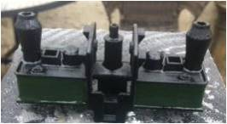
Fig 2 The chassis
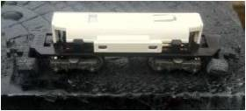
Fig 3 The completed kit
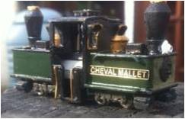
Mike Sharples
***********************
Features

Short Circuits No. 3. - How Hi/Lo can you get?
One of the features promoted for digital command control systems is the ability to independently control more than one train on the same section of track. To allow this facility to function requires lots of quite expensive and sophisticated technology. However it is possible to independently operate more than one train on a single section of track without having to resort to any complicated electrics or electronics.
One of the first major manufacturers to exploit this dual train facility in 00 scale was the aptly named Trix-Twin system. The main drawback to their system was that their own special track was required which had an extra centre insulated third rail which was not readily compatible with other manufacturers track. In fact Trix-Twin even exceeded their own expectations by becoming Trix-Triple, introducing their own catenary system thus allowing no less than three trains to be independently controlled on one section of track. On most real electric railways though, power is usually supplied by an outside third rail or overhead catenary and returned trough the running rails. It is the latter that Tri-ang Railways introduced in the 1960's.
Tri-ang overhead electric locomotives were equipped with fully functioning pantographs connected to a three position selector switch allowing you to collect power from the track, a neutral centre off or overhead catenary. Power was returned via the other common running rail as usual. The clever bit is how this facility was promoted and kept simple. Tri-ang used the term "Hi/Lo Dual Control" for this feature and stated that no complicated electrics or modified locomotives were required. Remember that in this era, toy or model trains were intended for a young clientele to play with and enjoy, not like the situation today where everything is obsessively scrutinised by self nominated mature gentlemen and the model railway hobby is taken far too seriously.
So how did Hi/Lo Dual Control work then? Very well indeed. The dual train facility exploited the principal of what is known common return. Don't panic! This subject will be dealt with in a subsequent article. What is required are two locomotives, at least one of which of course has to be an overhead electric locomotive and two line controllers. It is absolutely imperative that these two line controllers derive their input from independent supplies. One line controller is connected to the track in the normal manner and the other is connected, one wire to the common return rail and the other to the power feed mast on the catenary system. There is no difficulty having two electric locomotives on the line as long as one is switched to the track and the other is switched to overhead. However, the one working on the overhead must be orientated the correct way round. There is a little "R" indicating return or common on the bogie frame to assist in identifying this. If you study the associated Tri-ang Railways wiring instructions you will see just how simple the whole system is to set up and play with. Anyway, it's much easier than reading through this article again.
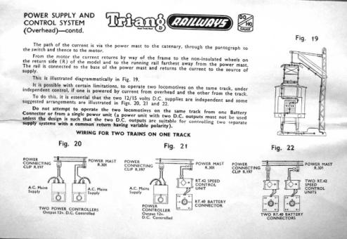

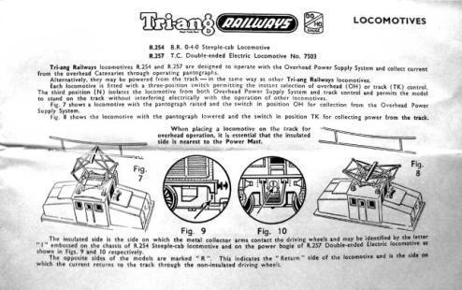
Allan Trotter

I wish that the following article had been available when Monsal Dale was being wired. Although we may not have used common return for the track power supply, tortoise motors and solenoid point motors in total, we did use it for the latter. And it was with these that we had a problem because we had multiple point motors in the circuit each with its own dedicated control wire (a sort of route control). To cut down on wiring as suggested by Allan we used a common return but the wire used was the same gauge as the control wire. This was more than adequate for one point motor over a short distance, but with two solenoids some distance from the supply the solenoid only worked feebly. For an explanation read on. Ed

Short Circuits No. 4. - Common Return is really Common.
Common return in electrical circuits is really more common that you may have thought. After all, planet earth is by far the largest common return conductor of all and it does seem to work rather well.
On model railway layouts it is an ideal way to reduce the number of interconnecting wires required between the control panel and your layout. In theory the minimum number of interconnecting wires may be defined as one wire per individual device or track section you wish to control, or two wires to each point motor, plus one single, and only one, common return wire. Even point control, whether it is solenoid or motor driven, can be reduced to one wire plus a common return. Using route control for points will also substantially reduce the amount of wiring too. More detail of those subjects though in subsequent articles.
However, common return does have an inherent downside especially for the complacent and the unwary. As the sum of the return currents of all the circuits is passing along this one single conductor, it is absolutely essential that this conductor wire is of as low a resistance as possible. Using heavy gauge wire such as solid copper mains earth return wire is one solution to reducing this resistance. It is essential that all devices connected to this earth common are terminated with secure connections. This is not the place to have sloppy and twisted dry joints, bare wire connections, or poorly terminated and soldered joints. Bad, resistive or even broken connections result in some really bizarre effects and can be time consuming to localise and fix. Not the situation you want to find yourself in within an exhibition environment.
Common return may be used for positive and negative earth common DC and also AC feeds to different devices and also for train control to track sections simultaneously. It is imperative, nay mandatory, that every power supply connected to this common return is derived from a fully independent secondary transformer source.
There you are, You have almost halved the amount of wiring you have to install on your layout. Can't be all bad, can it?
Allan Trotter

***********************

