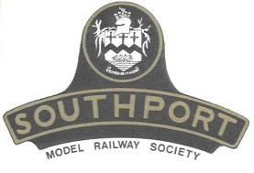 | Southport Model Railway Society  Newsletter  No 11: August 2012 Editor- Ian Shulver ( i.shulver@btinternet.com )

Welcome to this newsletter. We are now recovering from a long weekend at the ‘Woodvale Rally’ held last weekend in Victoria Park. We had four layouts on display – Saltash (its last public display under SMRS ownwership), Binns, Sandale and Shell Cove. Many thanks to those who provided layouts, those who helped set them up (and take them down) and of course to those who gave a few hours to operate them over the weekend. The Model Railway tent seemed busy at all times and we hope that our efforts and the high profile club display boards will give a fillip to attendance at our own show.
***********************

Chairman’s notes

Not content with visiting Paris in the add-on section of this year’s sleeper trip in order to ride Eurostar for the first time, the Good Lady and I took ourselves even further afield to experience and savour the delights of the Italian Lakes. We were based at the top end of Lake Garda and managed to explore many of the little towns nestling at the waters edge. It is a beautiful setting surrounded by rugged mountains, the small squares and piazzas basking in warm sunlight, the sight of sparkling waters seen from lakeside cafes were idyllic. What better way to spend time than quaffing a cappuccino or three and sampling the local pastries in pavement cafes for a spot of people watching. I had it in mind to catch a train down to nearby Verona in order to catch sight of Juliet at her balcony but it seems she was out or maybe washing her hair. So, due to time constraints, the nearest we came into contact with the Italtren service was glimpse their sleek lines from a (motor) coach window. Frustrating. You can guess gentle reader who is going back at their earliest opportunity.
The Woodvale Rally temporarily held this year at Victoia Park seemed to have enjoyed some moderate success, in particular for ourselves as we were able to distribute 800 of our smaller flyers promoting the forthcoming show. A great deal of interest was shown in Saltash, for its final public outing. It gave us all one last opportunity to operate and at the same time bid farewell to a classic layout. My thanks to all who were able to attend, lend a hand in setting up, operating, dismantling and representing and promoting the club. I hope that, like me, you were all able to enjoy and take away something from the event.

Frank
***********************

Monthly talks:
On Tuesday 10 July Mike Sharples gave a talk on “Irish Railways”. It was hoped that the meeting would start with a B-B-Q in our newly refurbished gardens (complete with ‘wild flower meadow’). Unfortunately the weather gods did not favour us with suitable conditions and so the ‘wet weather’ plan was substituted – an indoor B-B-Q instead courtesy of Tony.

Our next Illustrated Talk is scheduled for Tuesday 14th August and is to be given by Keith Gregory on “Signalling for Model Railway Layouts”. Please note that the venue for this meeting will be the Presidents Lounge at Southport Football Club on Haig Avenue starting at 7.30pm. Because of this there will be no preceding committee meeting.

***********************

Layout reports
Portland Street (Tony Kuivala).
Portland Lower - During this week we will be isolating then returning the two Controllers/Transformers to Gaugemaster as both have developed different faults.
Portland Upper - We have received some new industrial buildings plus other items. Corrective track straightening & re-ballasting is about to be undertaken.
Monsal Dale (Ian Shulver). There has been a reasonable amount of landscaping activity on Monsal Dale. Many thanks to those who have helped out with this. There is more still to do (as always). Hilary located and bought some sheep (thanks for that) but we will probably need more eventually. Telegraph posts are another requirement, as are signals. At this moment I think we will dispense with working ones and go for the Ratio ones (if I can find them),

Talisker Glen. No report forthcoming this month

***********************
Update on 2012 Exhibition(Tony Kuivala).
Many years ago we ran a Heritage Bus to/from Southport Station to our then venue at Meols Cop High School. In 2012 we are pleased to welcome Merseyside Transport Trust who will be running a frequent free service between Ainsdale and Hillside Stations to, and from, Birkdale High School on each day. A timetable will be posted on the respective websites closer to event.
From Sunday July29th and every Sunday to August26th plus bank Holiday Monday August27th Merseyside Transport Trust are operating a free-of-charge circular service taking in the sights of Southport using their preserved historic Leyland Atlanteans 1449 (GKA449L) and 1551 (OLV551) which had been operating these tours in past as Arriva services. More details at www.mttrust.co.uk

***********************

News from members

A report on the recent sleeper trip and add-on to Paris, together with photographs will appear in a future newsletter. The editor understands that this will be a collaborative effort with various sections from tour participants.

Allan Trotter reports that the Eastbank MRC web site has been relocated. The new URL is:
http://www.eastbank.org.uk Please update your “favourites”.
***********************

Features
Tri-ang Railways R249 Exploding Car
In the 1960's, Tri-ang Railways and Tri-ang Hornby introduced many unusual and ingenious operating models. One item that in no way could be described as an essential item for the serious fine scale zealot went with a bang, literally. It was of course the R249 Exploding Car which became part of the Battle Space series.
The Exploding Car was first introduced in the Tri-ang Railways ninth edition catalogue in 1963. Availability was indicated as ‘Summer’. It first appeared in bright red but later on Tri-ang Hornby changed the colour to khaki. Details and versions are well documented in Hammond 1 and 2. So how does it work then? Being a Tri-ang Railways operating accessory, it works very well.
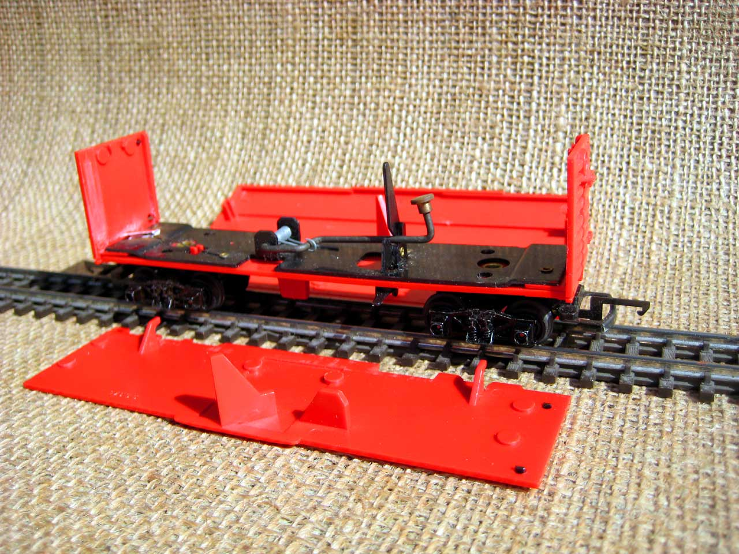
Comprehensive instructions are of course included and following these allows you to make the car go with a bang. With the car in a disassembled state the first thing to do is release the safety catch and prime the spring lever by tensioning the detonator against the tension of the spring. Once primed (fig 1) the safety catch is engaged preventing any premature release and yourself getting some very sore fingers. Now comes the delicate bit, fitting the explosive charge.
Having spoken to Miles about this, he stated that the explosive caps of today do not seem to have the same power as ones of the 1960's, that is assuming that they are obtainable in this politically correct and health and safety obsessed age. The ones I managed to acquire would not operate at first so an alternative method had to be sought out.
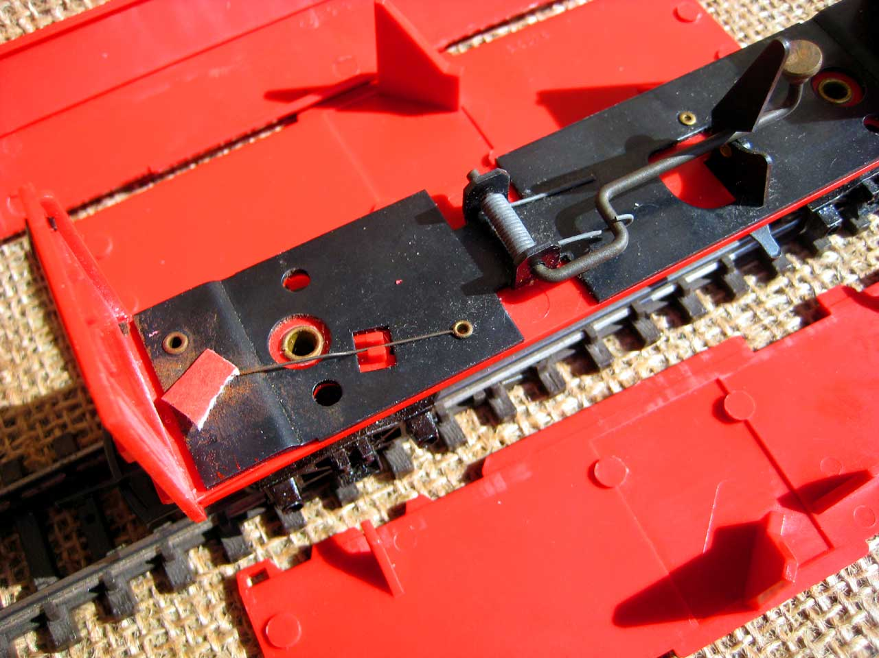
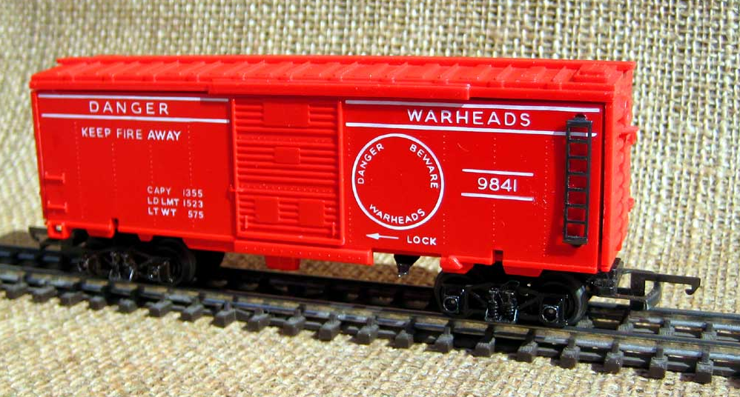
As always, the solution is simple. From the roll of caps tear off two caps at a time and fold between the two caps with the charge on the outside and insert this between the retaining clip wire and the base of the car, one on top with the other under the spring (fig 2). Again checking that the safety catch is engaged it is now time to carefully reassemble the car (fig 3).
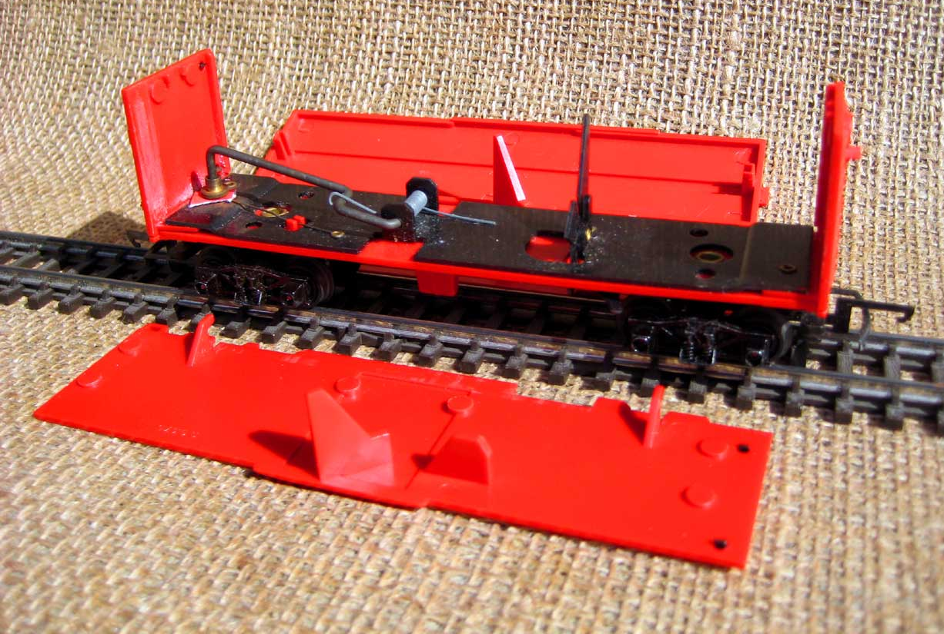
When you are ready to activate the car, carefully release the safety catch. When the car is tapped on the side with the circle, this side will tilt inwards and the associated cam will release the detonator lever. In doing so this lever will engage with cams attached to the two sides of the car and the sides will be thrown aside and the roof will also depart the car (fig 4). When the hammer at the end of the detonator lever hits the carefully positioned caps, it is bang on!
Once again, another innovative and entertaining model for the person that does not take their railway modelling too seriously.

Where’s Allan
Another for the ""Where's Allan" feature. It's not Scotland, it's not England, it’s not Scotland and it is a active station on Network Rail. Where am I? Answers please to the Editor in a sealed envelope.

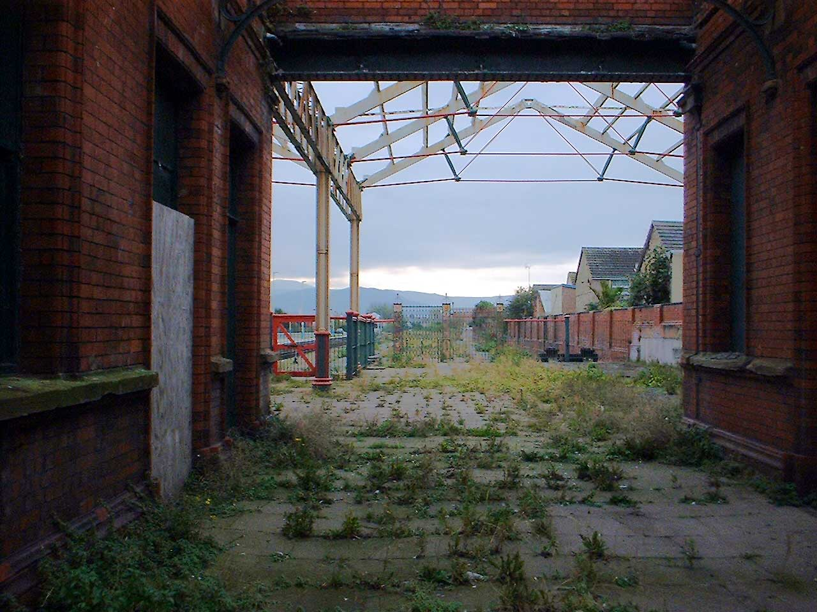

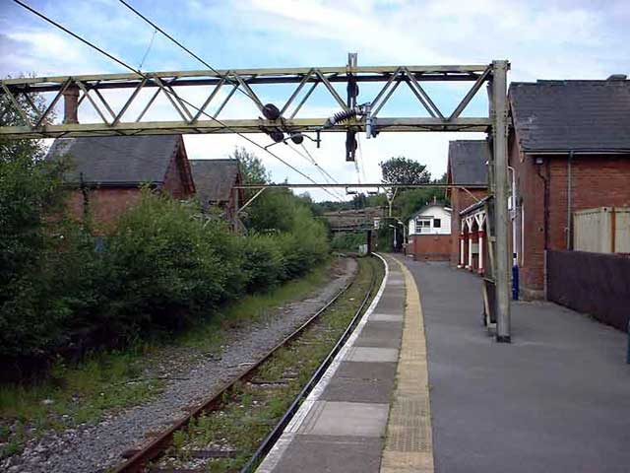
The answer to last month’s puzzling photograph is Dinting and the editor understands that a correct answer was forthcomng ( – name to be announced later).
The somewhat derelict looking platform is still in use. Dinting is the junction to Glossop off the former Manchester, Sheffield and Woodhead Line. Most people who visited Dinting went to look at the steam centre next door but I remained on the main line platform watching the electrics. I commented at the time that the Woodhead Electrics would be gone long before the steam engines. Unfortunately, I was right.

***********************

Forthcoming events
14 August Railway signalling for model railways (Keith Gregory) – NOTE VENUE Southport Footbal Club
18/19 August Midland Railex, Butterley
1/2 September Blackburn MRS exhibition
11 September IK Brunel (Ian Shulver)
29/30 Sept SMRC Annual Exhibition
23 October The Circle Line (Terry Tasker)
20 November Ravenglass & Eskdale Railway (Peter Mills)
December An Italian themed evening (Jim Ford)

