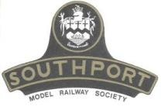 | Southport Model Railway Society  Newsletter  No 34: August 2014 Editor- Ian Shulver ( i.shulver@btinternet.com )

Hopefully next month’s edition of the newsletter will see Peter take over as editor. Apparently up in the far north there has been much activity by BT moles and his BT landline and internet connection had been dug up and he sort of lost contact with the rest of the world for over a month.

Ian - Editor

Chairman’s notes:
Once again yours truly is to be found out in the garden using any excuse to make the best of the present spell of fine weather. The current excuse is so that I can bring the 16 mm garden layout to fruition but as we all know a model railway even a garden one is never finished. Cunning eh? Now while this weather is ideal for those sun worshippers working outside it's not so for those working inside, my case in point being the wallpaper stripping and preparation work of the rooms upstairs at Portland Street. The use of a wallpaper steamer coupled with the midday heat will have made it like an oven (or sauna) in there. However, undaunted our stalwart band have reduced two of the walls to bare surfaces in fact one wall back to bare brick work so poor was the old plaster resulting in in many bags of rubble destined for the tip. Fear not though there's plenty more to be done, so if you want to lend a hand don't be shy. After all the sooner the job is done the sooner we can have Portland Street up and running again.

Frank
***********************

Monthly talks:
The July talk, or rather slide show was given by Allan Trotter. This was titled “Ships on the Clyde, the English Channel, and more”. Some fascinating “footage”
The next talk will be on Tuesday August 12th at Jim Ford’s where he, and co-opted colleagues will provide instruction in the mysterious art of firing and driving radio controlled 16.5mm steam locos. This will be at an earlier time of 6.30 in order to make best use of daylight hours. It will be followed by food when the light fades.
***********************

Layout reports
Portland Street - Upper & Lower (Tony Kuivala). Currently out of commission until the room has been redecorated.
Monsal Dale (Ian Shulver) – No action here, but a working mock-up of the points and wiring for the crossover in the fiddle yard has been constructed to ensure that conflicting set-ups cannot be made. All we need now is to get some suitable points and get to work!
Talisker Glen. As with Portland Street, Talisker Glen is out of commission until the room has been redecorated. Once completed work on the layout will recommence.
***********************
2014 Exhibition Continues to fall into place. More details in the September and October newsletters.

***********************

Forthcoming events
The programme for the next few months is as follows:
August 12 Learn to drive a radio controlled 16.5 steam train – Jim Ford
September 16 2014 Sleeper trip – Derek Pratt
October 14 Colorado Railroads – slide show. – Robin Green
Nov 8-9 SMRS Annual Exhibition
Nov (TBA) Backscene painting – Hilary Finch
***********************
57a Redecoration
Internal: The gable wall in the Portland Street room has now been stripped of its paper. Much of the underlying skim plaster has been affected by dampness and needs to be cleaned back to expose a solid surface to mount the plasterboard on. The wall facing the railway line was in a very poor state, necessitating removal of all the old plaster back to bare brick. However, before any plastering can be undertaken on this wall, the cracks will need cutting out and re-cementing ( we suspect that some of the dampness has been penetrating along these cracks).
External: Nothing further to report
***********************
Member’s news:
Further snippets from “ Leaves on the Line – letters on trains to The Daily Telegraph”, edited by Gavin Fuller.
25 OCTOBER 2002
FASCINATING HOBBY
SIR — I am a model railway enthusiast specialising in the Swanage Railway. In a recent radio programme trailer, I was sorry to hear a trainspotter, who owned a model railway, portrayed as socially inept when dating a woman. I am astonished that such a harmless, creative and fulfilling hobby has become the butt of mindless jokes from the media.
Trainspotting began during the Second World War when Ian Allan produced a pocket-size book called Southern Locomotives, which was a complete list of all the 1,850 Southern locomotives in service in 1942. This eventually included all the locomotives in service on British Railways and was updated each year. The information gained from
people who used this book to collect engine numbers has been a valuable source of information for authors and railway modellers.
People who build and run model railway layouts are as far removed from the media’s image as it is possible to be. West Wittering Model Railway Circle produced a beautiful model of Swanage Station. The builders included a doctor and his family, a leading author, a teacher and an engineer.
The model did not only authentically recreate the trains and the railway buildings: it was a three-dimensional picture of what life was like in Swanage in the early 1960’s. It included Court Hill, the laundry behind Gilbert Hall and the garage that stood on the site of the Post Office. Abou4 10 years ago, we exhibited it in the Canon Hall in Victoria Street.
I cannot understand why people who have worked so hard to provide so much enjoyment for themselves and others should be subjected to such facile comments from the media,
Robin Brasher
Swanage, Dorset

29 OCTOBER 2002
SIR—I agree with everything Robin Brasher says except for his claim that ‘train spotting began during the Second World War’ (letter, Oct. 25).
I am a member of a rare breed - a female railway enthusiast - and I was train spotting as early as 1935 (as did my family before me). There were no Ian Allan books then; we produced our own stock books. As I was only four in 1935, I put my later affinity with numbers and a career as a maths teacher down to all those numbers I had to record.
Susan Youell
Leeds

30 OCTOBER 2002
SIR — Trainspotters have been around since the 1890s, when the Railway Club was founded, not the Second World War (letter, Oct. 25). About that time, GA. Sekon, for whom my mother worked briefly 85 years ago, founded the Railwqy Magazine. The Railway Correspondence and Travel Society was founded in 1929. With other railway societies, it continues to flourish. Ian Allan seized on already widespread interest to give the average enthusiasts what they wanted in pocket form.
In more recent years, railway enthusiasts have rescued branch lines and steam trains from oblivion, and founded transport museums; they preserve historic engineering and woodworking crafts. Their efforts are now a useful part of heritage and the tourist industry.
Some of us have devoted our energies to the consumer movement, providing expertise, at no fee, that counters the efforts of railway managers to pull the wool over the eyes of rail passengers’ consultative committee members.
Railway enthusiasts are at this moment voting for Brunel, railway engineer, as a Great Briton. As for being socially inept, well so can gardeners, hill walkers and stamp collectors be. But is that worse than being the opposite - Costa del Sangria tourists, party ravers and viewers of Fame Acadeny?
Laurie Mack Bromley,
Kent

.

***********************

Features

Continuing with Allan’s series of papers on electrical matters. If you wish to see the preceding articles, they are all to be found on www.eastbank.org.uk .

Short Circuits No. 14 - Make mine a Double.
As mentioned in the previous article, the energy stored in a capacitor is proportional to the value of the capacitance and also proportional to the square of the voltage supply. To coax more energy from a CD unit there are two possibilities. One is to increase the value of the capacitor and the other is to increase the operating voltage.
Increasing the capacitance requires larger and more expensive capacitors but increasing the supply voltage is relatively inexpensive. Be warned though, before doing this make sure all the components are suitably rated for the increased voltage. Do not operate any components beyond their recommended safe tolerances. Doubling the voltage results in four times the energy in the capacitor.
Usually the only power supply available on model railway layouts is either 12 volts DC or 16 volts AC. For this voltage booster we use a modified version of the +12 and -12 volt power supply unit as used previously. To be absolutely clear, the voltage difference between +12 and -12 is of course 24 volts.
It is essential to use a 16 volt AC supply as the two capacitors are charged up on the alternating cycles of the AC supply. Again the capacitors charge up to the peak value, not the average value, of the supply, about 22 volts. This gives an output of about 44 volts DC. This supply is connected to the input of the CD unit and gives an output of about 44 volts with four times the energy of the 22 volt version.
Is this higher voltage safe in a model railway environment? Indeed it is. Because the transistor switches off very quickly the solenoids cannot be overloaded. The higher voltage is quite safe as the energy is delivered for a very short time only. Touching the terminals will cause no real sensation unless your hands and body are very wet and you are standing naked in a half filled bath. You wouldn't want to be doing that, now would you?
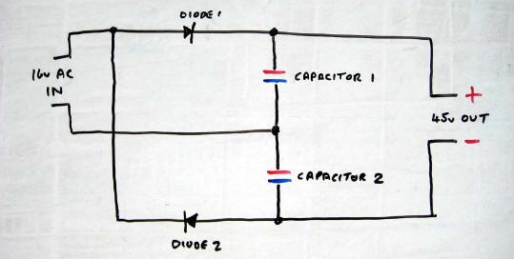
Voltage Boosting Circuit
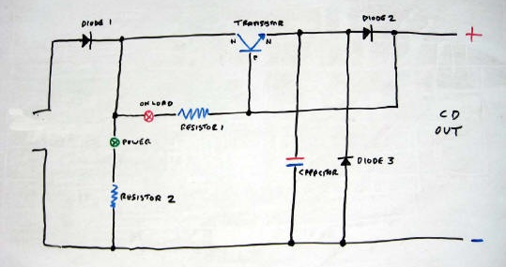
Fast Recovery Higher Energy Capacitor Discharge Unit

