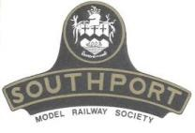 | Southport Model Railway Society  Newsletter  No 37: December 2014 Editor- Peter Mills (dogboy2000uk@yahoo.co.uk)

Editorial
Welcome to the December issue of our newsletter and my first as editor. It has been a long and protracted IT journey to get to this point and BT played their part in displaying the appalling service in repairing phone lines to the whole row of houses where I live. Whilst that has been going on, Ian has kept the newsletter going and my first official duty is to thank him for his help in the last couple of months or so. The newsletter is one of our successes that keep everyone up to date with news and developments within our club. As I said in my recent email, this is your newsletter, so the more contributions I get the better and the less chance there is of rantings from a Ratty Driver.
We are fast approaching the time of year where we are given gifts and we buy gifts for our friends and family. I would like to think that there is a certain amount of model railway gifts being bought for us all in the coming weeks, adding to our already bulging collection of items that we each have to make our collections better, but I’m sure that our other half’s wouldn’t necessary take this view. I fell a bit like a Lib Dem, saying that I didn’t much care for DCC and now find myself at the point of picking a DCC system to buy. So I hope that as the year comes to an end, you are perusing your interest within our hobby and are enjoying having a go.
For future issues, I intend to send out an email asking for copy in the last week of each month, please DO NOT send any earlier unless previously agreed. I would like the articles to be send as a word document attached to an email and any photographs that are submitted to be sent in JPEG form. Once I have all the material, the magazine will then be published in the first week of each month.
The final thing for me to say is to wish you all a Merry Christmas and a happy New Year.
Peter

Chairman’s Notes
This time a slightly different message and way of bringing the end of the year to a close, in as much that as we reflect on our recent show then in the next breath it is looking towards the Christmas season.
The 41st Southport Model Railway Exhibition is, happily, once again deemed a success. During the two days duration I heard and heard of compliments and positive comments about the show and of the catering from exhibitors and traders, as well as seeing apparently happy faces on our visitors despite at times, some unfavourable weather. I noticed this year a quicker and smoother setting up / dismantling all this despite again those same unfavourable conditions at either end of the event and it looks like we are getting the hang of this exhibition thing. Seriously though I wish to thank each one of you for your efforts and contribution throughout which ensured another satisfying and enjoyable success for one and all.
Which brings us to the Christmas season. I hope you were able to reward yourselves with some early gifts from our traders or failing that hope that your Santas bring you something from your wish list. In the meantime I'll take this opportunity to wish you and yours a restful peaceful and Happy Christmas and a prosperous 2015.
Frank

Elsecar Garden Railway Show
With the Southport Model Railway Exhibition being staged in November 2014 meant that it would be possible to attend the Elsecar Garden Railway Show. This for me was an almost once in a lifetime opportunity to attend because it has historically been held on the last weekend of September, therefore clashing with the Southport show dates. Realising that this was a chance not to be missed I set about plans for a visit even inviting my good lady wife to accompany me so that she might enjoy the other attractions of the nearby Heritage Centre.
The show itself was very well presented with 6 layouts operating live-steam locos and it was good to see familiar layouts (like Dixon Green using a type of Astroturf to good scenic effect whilst a syncopated jazz train ran through) along with the less familiar yet equally entertaining displays. Similarly there was a wide selection of traders with a tempting range of goodies to which I failed to resist. I was even treated by the good lady to a new carriage kit as a belated anniversary gift. After exhausting the pleasures of the show we moved on to enjoy and sample the outlets of the surrounding Heritage Centre and the Elsecar Heritage Railway.
The Coalfield Memorial Line railway is the former Elsecar Branch of the South Yorkshire Railway, opened in 1850. The single-track mineral line ran from Elsecar to Mexborough, via Cortonwood, serving local collieries and ironworks. Earl Fitzwilliam, of Wentworth Woodhouse, ran private passenger trains from his own station at Elsecar. The branch wound down and closed when, in 1984, Cortonwood colliery shut. When Barnsley Council decided to open Elsecar Heritage Centre the railway was reinstated as part of the attraction, the first passenger train running in 1994. The first engine was named Earl Fitzwilliam. In 2006 the operating responsibility for the line passed to Elsecar Heritage Railway. The line currently runs for one mile from Elsecar to Hemmingfield and it is expected soon to open a further mile to Cortonwood.

This had been a full and very interesting day. Discount on railway ticket price is given to visitors to the show and also includes a conducted shed tour. This is worth a return visit, even if not on the show days as work continues in the development of the line and it's surrounding features. In particular I look forward to visiting the Newcomen Engine House which nears completion.

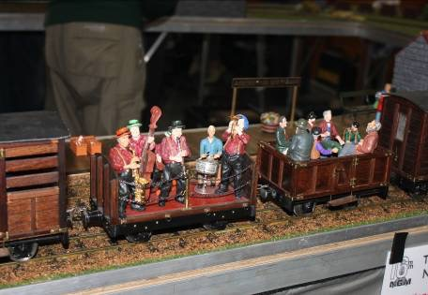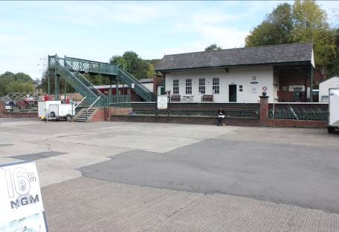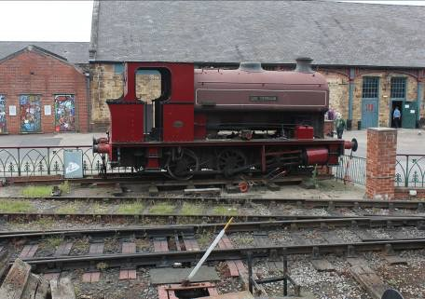

Secretary’s Report
None to report

Exhibition Manager’s Report
2014 Exhibition is successfully concluded. Increasing Adult admission charge to £6 did not impact on numbers and overall income was near enough to Budget. Nor were we apparently affected by date of date. Overall financial result is a surplus which is higher than 2013’s. Our local publicity through Press and local magazines was very significant. On the downside are Layout costs. These have been increasing significantly year on year. The current article in Chiltern’s Newsletter sums up views that we have discussed within our own Committee in early 2014. We mustered 23 Layouts through some late calls on our Members after Copperhead Crossing and Florida City withdrew late on through understandable health features. These were from well outside North West England – Isle of Wight and Hagley in Worcestershire respectively - as part of our philosophy of bringing to Southport Layouts that are not normally seen here. Such Layouts, because of the costs involved, challenge and encourage us to annually refresh our offerings. Same applies with Traders. We would have had five new but unfortunately Models4U (from March in Lincolnshire) withdrew the weekend before, afflicted with an unfortunate injury. Some interesting and valuable features arose in our Exhibition Feedback Review, these will be actioned as part of 2015’s preparations.
Looking towards 2015 Exhibition on 07th & 08th November there are 13 Layouts already booked, five of which are from outside this area. At this point there will be a pause until into New Year as other influences take over. Our expectation is a minimum of 20 diverse Layouts.
Tony.

Layout & Club News
Monsal Dale (Ian Shulver) - As mentioned in last month's nesletter one of the fiddleyard points has now been relocated and now wired up but not tested yet. A start has been made on fitting the second point and although I am still concerned about fitting in the new “Y” point and ensuring there is a sufficient length in the loop for the “Blue Pullman”, I think we will just about be OK (the driver will need to stop with pinpoint accuracy). The extra point motors have now been identified and tested.
57A - Internal. We had a hiatus in continuing with the decoration the Portland Street room whilst preparation for the exhibition were under way. Now that this is safely behind us, we can continue and it is hoped that early in December the ceiling will have been painted and the layout moved across the room to its second temporary position.
External. Tony put in a sterling effort early in november cleaning up the woodstore and the garden. This was necessary so that we could store the wooden barriers now that Dereks garage is sadly no longer available to us (many thanks Derek for the use of it for the last couple of years). After carefully stacking the barriers and sheeting them, we needed to rope everything down, but of course we did not have any at the time. Although this (the rope) was procured the next day, the weather turned against us (torrential rain) and so the following period of gale force winds rather undid all our good efforts. However, all is now battened down and should survive the worst that the weather can throw at us.

Member’ News
As you are probably aware the cistern in the outside loo has been loose for some time and potentially could have become detached. We have been pushing it back towards the wall, but of course the vibrations from the passing trains undo all our good work. You will now be relieved (pun intended) to know that this has been repaired. You might well ask why the sudden maintenance activity. Well, it all came down to a book I was recently reading. This was a detective novel by James Oswald called The Book of Souls and was set in Edinburgh. In this, one of the cases Inspector McLean was involved in concerned the discovery of a body in an outside convenience. As it turned out the cause of death was being hit on the head by the cistern falling of the wall. Now, not wanting a similar fate to this happening to myself or any other august member of our Club, I thought I had better do something about it. You can sit in comfortably in the safe knowledge that you will be safe from falling cisterns.
Ian

For those members who are also a member of the DHRS, your editor has an article in the December issue of the Darjeeling Mail regarding my visit with Tony to the South Tyndale railway and their ‘Indian Summer Hills’ Railway event.
Peter

Talks

The December talk will be on Tuesday 16th and will be given by Jim Ford. His subject will be "The Developments of Railroads in the USA with particular emphasis on Colorado" and will complimentary to Robin Green's slide show that he did in October. The venue will be at Jim’s (42 Hesketh Road). This will be followed in January (13th) by a selection of slides from Allan Trotter showing real mansize railroads in Colorado, Kansas and Wyoming

Forthcoming events
The programme for the next few months is as follows:
December 16: The Developments of Railroads in the USA with particular emphasis on Colorado. Jim Ford
January 13: The Real Railroads of Colorado, Kansas and Wyoming. Allan Trotter
February 17: Mega points - a demonsatration. David Fenton
March: Amtrak: Trains and Travel. Allan Trotter
April: A life in 86 minutes - the work of Geoffrey Jones. Jim Ford
May: The Chicago, South Shore & South Bend Railroad. Allan Trotter
June: Quakers and Railways in Great Britain. Ian Shulver
July: Painting backscenes. Hilary Finch
August: Statfold Barn. Tony Kuivala
September: no talk (depleted membership)
October: A celebration of the trip to Colorado - a selection of tour member's photos.
November 7-8 Southport Model Railway Exhibition

