Southport Model Railway Society
Newsletter
No 22: July 2013 Editor- Ian Shulver ( i.shulver@btinternet.com )

We are now into the holiday period (the sleeper trip usually marks the beginning) as well as it is peak activity time in the garden (weeding, cutting the grass and hopefully sunbathing). Railway modelling thus seems to go on the back burner so I thought it would be nice if this issue contained a couple of short modelling articles. This decision was also driven at the time by my supply of copy for articles drying up – I did warn you that unless you got writing the newsletter size would shrink. Although too late for this issue, in the last few days I have fortunately received enough articles from our regular contributors, and one other, to keep me going for the next couple of newsletters. However, I still need more so that I can put together a balanced document. So, this is addressed, not to our regular contributors, but to you – get writing.
Ed
***********************
Chairman’s notes
By the time you read this the Sleeper Trip party will be on the other side of the Irish Sea having survived what will hopefully be a calm and peaceful crossing. We are intending to see some of the unexplored railways and/or remnants thereof still to be found in the southerly parts of the Republic. We will no doubt be able to inflict our experiences on you through the Newsletter. Or you could perhaps beat us to it by submitting your own articles. I know Ian would welcome more written pieces from us all, anything of a railway based theme but particularly of a modelling nature. Also while on the subject of modelling, a reminder for your competition entries for a ‘Layout in a box’ in time for this years show. With just a little over three months to go to complete them it would be great if we could exceed last years excellent effort in this our 40th year of modelling.
Frank
***********************
Monthly talks:
Our next talk will be held on Tuesday 16th July when Ian Shulver will describe the trials and tribulations of the Mid Suffolk Light Railway. This will be at Ian’s – 32 Curzon Road
June 18th was the date of our last talk when Derek Pratt discoursed on “Industrial diesels of the North West”.
***********************
Layout reports
Portland Street - Upper & Lower – No report
Monsal Dale (Ian Shulver). This had a very successful outing to the Woodvale Rally. With exception of one fiddle yard point motor which failed to function correctly (to be investigated in the comfort of the clubrooms), the layout performed extremely well and attracted many favourable comments. From my perspective, we need to do a little more super detailing.
Talisker Glen. No report
***********************
2013 Exhibition (Tony Kuivala).
With two exceptions all the paperwork is in place. We have twenty three layouts, twenty one trade (including two new to us), fifteen societies and six demonstrators.
***********************
Forthcoming events
The programme for the next few months is as follows:
July 16 The Mid Suffolk Light Railway. (Ian Shulver)
Aug 10-11 Leyland exhibition (Monsal Dale)
Aug 15 Southport Model Engineers “40 Years of SMRS”. Tony Kuivala and Jim Ford
Sept 28-29 40th Exhibition
September German Railways (Peter Clare)
October Title to be declared (Peter Mills)
November How to use Paverpol (Shirley Tasker)
December Rails in the North (Jim Ford)
***********************
Features

A simple and quick load of coal.

In the real world, coal wagons are either full or empty, with probably equal proportions of each. However, the proprietary model world seems to be populated by wagons that are empty. If a manufacturer does deign to provide something to put in the wagon, it usually looks nothing like the real thing.

To make a load of coal look realistic, there is nothing like using the real thing, but a 25 rake of coal wagons, each filled to the gunnels, would be quite a load for a model locomotive and would probably mean that it would expire before many circuits. So how do we ameliorate this?

After much experimentation, I decided to try foam rubber. The advantage of this material is that it can be cut to fit the wagon and if cut marginally oversize, its natural resilience means that it will stay firmly in the wagon, even when inverted. The big problem was how to get the coal to adhere reliably to the foam.

The procedure is as follows and although tried and tested for use with 2mm scale wagons, there is no reason why it cannot be used for 4mm, or even bigger scales

Firstly, procure a supply of foam rubber, preferably dark grey or black and as dense as possible. If grey or black is not available then try soak the foam in permanent black ink and dry. Cut the foam into strips which are marginally larger than the wagon, but are 1-2 mm less than the internal height. Carefully chamfer the top edges and make the top a little uneven.

Now for the coal. Obtain a few small pieces and roughly crush. Use a kitchen sieve and then re-crush the rejects. Continue doing this until you have enough (a small lump of coal makes a surprising number of loads). Use various sieve sizes to get the size of coal you need remembering that coal as supplied was anything up to 6” in diameter (1mm in N gauge, 2mm in OO).

The coal now needs sticking to the foam formers. To do this I place them on a large sheet of newspaper, right way up, and carefully coat with spray adhesive. Once coated, transfer, to a clean sheet of paper. Then cover with a good layer of the aforementioned crushed coal and press lightly down. Leave to dry for a few minutes and check that the covering is to your satisfaction. If not, lightly spray again and add further coal.

It is best to leave the coal covered foam to ‘cure’ overnight before installing in your wagons. The advantage of this method is that it is light, looks good and, if necessary, the coal load can be easy removed.

Ian Shulver

Short Circuits, an Introduction. - model railway electrics made easy.
Don't be put off by the main title. It's not the circuits that are short, it's the articles.
This regular series of articles on model railway electrics is intended to, with the editor's and members' approval of course, be published each month with the intention of giving an insight as to the many simple ways to get the most operational fun from your train set or if you take things a bit more seriously, model railway layout. The articles and associated diagrams are intended to demonstrate practical and inexpensive explanations to many of the electrical control situations encountered when designing the control system and wiring for your layout. Of course this subject of model railway electrics has already been well documented in many commercially published books but these books all have one thing in common, they tend to very quickly become complex and full of a lot of inane and unnecessary technical theory and jargon. Be assured, this will not happen here.
Note that all the articles and any wiring plans in this series pertain to two rail conventional analogue DC systems only and not to three rail DC, three rail AC nor to any aspect of Digital Command Control systems.
If there is any relevant electrical subject that you would like to see included in this series, please respond and I shall attempt to cover it.
Now for your assistance. Please inform the editor if you find the "Short Circuits" series interesting and useful and they will continue. Alternatively, please inform the editor if you find the articles irrelevant, too simplistic or even downright boring and they will cease forthwith. Whatever you do, please respond!

Short Circuits No1 - Which way is forward?
This may seem at first to be an odd question but there is a convention that has been used for more than sixty years concerning this very subject. Model railway manufacturers the world over have all adhered to this convention resulting in when you put your train on the track and turn on the controller, the train will proceed in one consistent direction.
The convention states that when the furthest away rail is more positive than the nearest rail, the train moves to your left. Reversing the controller makes the furthest away rail more negative than the nearer rail, therefore the train moves to the right.
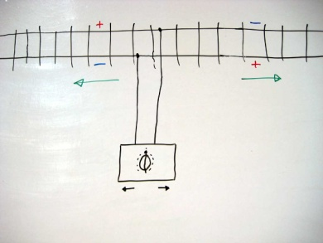
If your train does not adhere to this convention, you have a faulty train. This error could be due to a number of reasons. If the loco is brand new then there is a manufacturing fault and it should be returned to the retailer as being not fit for purpose. However, on older pre owned models, common reasons are that the magnet has become reversed or that the wiring to the motor has been reconnected incorrectly. If directionally controlled headlights are installed, it is important to ascertain whether the headlights and travel direction are in synchronisation. Reversing the wiring to the motor or lighting will remedy the problem.
Why is direction important? You really want all your trains to run the correct way for ease of operation in running, shunting and is of course it is absolutely essential for double heading or banking purposes. Also, as we shall see later in the Short Circuits series, control circuits utilising diodes will not work as intended on reverse wired locos. Don't end up going backwards. It's easy and it's worthwhile to get your direction correct.

Allan Trotter
***********************
Where’s Allan
Not too many clues this month other than to suggest that this might be a London station. Where is it, and more importantly, a date (year will be fine)? – UK0521.
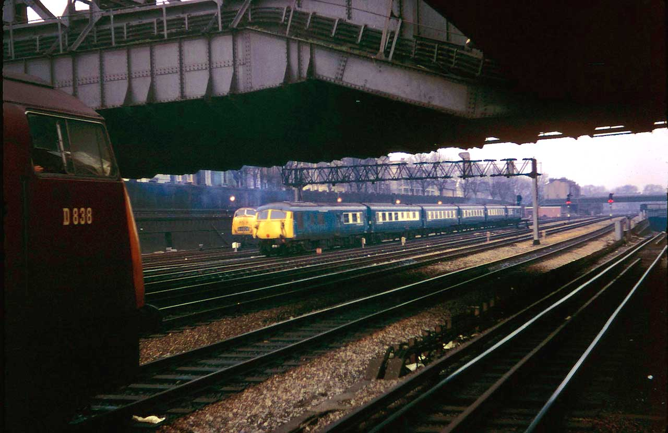

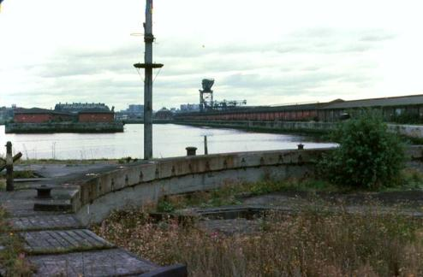
Last month’s “Where’s Allan” said “This is one of the many docks on the River Clyde but surprisingly enough most club members have been here walking or even driving in this area. The crane in the background is a good clue. The docks have now been filled in. The answer is: Queen's Dock, Finnieston, Glasgow in 1977 and on this site now stands the Scottish Exhibition and Conference Centre (SECC) where Modelrail Scotland takes place.
***********************

