|  |  |
| --- | --- |
| logo | **Southport Model Railway Society**  **Newsletter**  No 23: August 2013 Editor- Ian Shulver ( [i.shulver@btinternet.com](mailto:i.shulver@btinternet.com) ) |

.

**Chairman’s notes**

Well into the summer season now, and the extended sunny period has been tempting me (like I need tempting) out into the garden for a further spate of track laying and light civil engineering  involving earth movements. Rather than waiting for the rainy periods to work indoors everything is being done al fresco for the moment, including writing these notes.   
Elsewhere I hope this fine weather, should it continue, does not have an adverse effect on potential visitors to Leyland Model Rail Show, where we are showing Monsal Dale, and the West Lancs Light Railway's Summer Gala both on 10th and 11th August. Thanks in advance to all of you for putting your names forward in support and look forward to seeing you all there.

Now if you will excuse me the sun is still out and still loads of jobs to do!.

Frank

***********************

**Monthly talks:**

We do not have a formal talk this month, but Tony and Jim will be giving a talk at Southport Model Engineers on Wednesday 14th August about our Club History. More details to follow.

Our last talk will be held on Tuesday 16th July when Ian Shulver described the trials and tribulations of the Mid Suffolk Light Railway, a much loved but ill conceived railway and after 60 years has now almost completely been subsumed by the surrounding countryside. Our thanks to Ian and Heather for hosting this (particularly Heather’s lemon and chocolate mousse) and for having the courage to have the whole event outside (fortunately it was a beautiful warm and still night.)

***********************

**Layout reports**

**Portland Street - Upper & Lower** (Tony Kuivala) **-** Both Layouts are operational and in constant use notwithstanding some irregular faults overdue for attention. Now that our busy summer of 40th Anniversary activities takes a pause until Exhibition in September we have the opportunity to get on with alterations to Control systems, relay some badly distorted track, continue with ballasting, enhance scenery plus sundry other activity. We will be resurrecting the brilliant teams that achieved so much earlier this year and 2012.

**Monsal Dale** (Ian Shulver) - Little to report this month. The drystone wall that went missing at the Woodvale Rally has now been replaced and a couple weeping willows placed on the banks of the River Wye. A concerted session on tree/bush making will be required in the future.

After dismantling the dodgy fiddle yard point motor found at the Woodvale rally, it was concluded that the problem must have been a dry solder joint. It now appears to be working perfectly.

The next outing for will be to the Leyland exhibition on 10/11th August.

**Talisker Glen**. No report

***********************

**2013 Exhibition** (Tony Kuivala).

We are about to pass first draft of Exhibition Guide to Printer. John Mawdsley has sold Gaynors to Watkinson’s in Churchtown and taken well earned retirement. Fortunately we continue to deal with the same staff and enjoy the same beneficial arrangements.

Listings of layouts and traders have been posted in the clubrooms, on our website and sundry other places. Localised press releases will be issued shortly including the news that for 10th consecutive year we will be graced with the presence of our Mayor.

An innovation for 2013, (thanks to Allan Trotter, is that we will offer a service to transfer 35mm colour slides to a digital format. As no fee will be charged there will be a limit of four slides.

Merseyside Transport Trust will be running a special Classical Bus service – no fares charged – between Ainsdale Station and our Exhibition. Timetable etc will be published in mid September.

***********************

**Forthcoming events**

The programme for the next few months is as follows:

Aug 10-11 Leyland exhibition (Monsal Dale)

Aug 10-11 West Lancs Light Railway Summer Gala

Aug 14 Southport Model Engineers “40 Years of SMRS”. Tony Kuivala and Jim Ford.

**Sept 28-29 40th Exhibition**

September German Railways (Peter Clare)

October Title to be declared (Peter Mills)

November How to use Paverpol (Shirley Tasker)

DecemberRails in the North (Jim Ford)

***********************

**History of the Club**

We have just published a definitive version of the History of Southport Model Railway Society since its inception in 1973. This is a 28 page pamphlet with contributions from a number of members and includes, amongst others, chapters on the early (and recent) history, our N gauge layouts, sleeper trips and other social activities and a list of past officers.

This document is available from the editor ([i.shulver@btinternet](mailto:i.shulver@btinternet) or 32 Curzon Rd, Southport, PR8 6PL) in either a pdf format (£1.00 donation to the club please) or as a hard copy (booklet format) for £2.50 (includes postage).

***********************

**News from members**

*Peter Mills has recently returned from a excursion to deepest Sussex and the Bluebell Railway. This is his account of that trip.*

**A Journey on the Bluebell Railway - *East Grinstead to Sheffield Park***

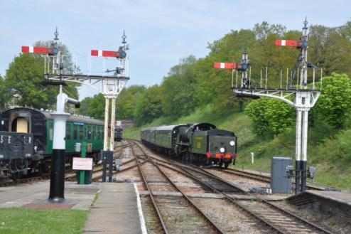The Bluebell Railway is one of the more well known standard gauge preserved lines in the UK. It was also one of the first to start a preservation movement to save the line over 50 years ago and it was the first standard gauge preserved railway. The preservation Society was formed at the time, by four students and mentor Bernard Holden who worked in the rail industry, including overseas service during the war. He went onto become the president of the society and led a full life working towards the long term goal of connecting the Bluebell to the national network at East Grinstead. This was finally achieved early this year after long and successful fundraising including 5.5 million pounds to remove waste from Imberhorne cutting. Unfortunately for Bernard, he passed away at the age of 104 just before completion at the start of 2013. However, the highest point of he line is in the cutting and the summit has been named  'Holden Summit' in his honour.

To get to the Bluebell, you need to catch the train from London Victoria to East Grinstead and the journey takes in the region of an hour. There is now a new terminal station for the Bluebell there, it is a new build a lacks the character of the other restored stations on the line, but it is functional and fits into the small area between the local supermarket and the mainline Station.  
The reinstatement of the final extension from Kingscote to East Grinstead takes the length of the line to 11 miles. As soon as you leave the new terminus, you cross an impressive viaduct of some length and immediately start climbing at 1:60 through Imberhorne cutting. The latest extension into East Grinstead is a fairly short one of 2 miles or so, but it gives the Bluebell access to the lucrative London area charter market. 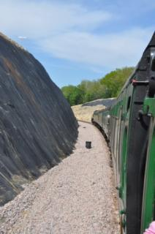

We quickly arrive at Kingscote, this represents a classic 1930's Southern Railway country Station which was the northerly terminus for the railway but was subjected to severe restrictions after objections, including no parking on site, just a run round for the bus connection to East Grinstead.   All too soon, we leave this idyllic country station and carry on towards the next stop at Horsted Keynes. On the way, we pass a disused station, but the Bluebell isn't allowed to reinstate and use it after objections from local residents.   This to me is a curious thing given the economic benefits that preserved railways bring, but given the affluent nature of the area, maybe not so curious.

We head straight into a tunnel of quite some length, which is one of the other major features on the line. If conditions are right, the compartment fills up with smoke before emerging once more into the wonderful West Sussex countryside. We arrive at Horsted Keynes in no time at all. This is the major station on the railway with 5 platforms and an extensive yard that includes the Carriage & Wagon Department. They regularly restore a mix of Southern Railway and Southern region BR coaches to the highest standard on preserved railways that I have seen. It once formed a junction with the line to Ardingly and Haywards Heath. The Bluebell owns all this trackbed and it forms another long term goal for the railway. This also is the station were trains pass on their respective journeys a lot of the time. Sometimes alongside the normal running of service trains and dinning trains etc can be a footplate experience courses often using the unique Terrier class locomotives on the line. It would make a great station to model and it can be a good place to watch trains.

We continue south towards Sheffield Park, through the rolling countryside. Along the way there is plenty of activity alongside the running of the trains such as p/way activities from spot ballasting to burning gangs. The other pleasing sight to see was a youth group called the 9F club, (20 or so young volunteers with several adults working on various areas on the railway). From what I could tell, the age of the group ranged from about 10 to 16. In fact there were several other young volunteers being mentored by guards and buffet attendants in their respective roles, it was really good and refreshing to see. All too often these days, visiting a standard gauge railway seems like being on the set of the film cocoon and if programmes and training like this is not put in place, then it will effect the preservation movement in a big way with lack of volunteers in the future.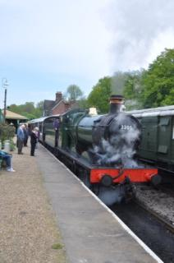

Again, you get caught up in the scenery and arrive at Sheffield Park before you know it. Here has seen recent expansion with the creation of a carriage shed to house stock under cover. It is also the home of the locomotive shed where the bulk of steam locomotives are based. There is a great variety of engines to see from BR to S.E.C.R, all restored to an exceptional standard.

On my visit, it was timetable two, which consists two normal service trains. One of which   is normally a heritage set made up of Metropolitan Railway non-corridor coaches and alike. This was pulled by a visiting Great Western locomotive. This heritage train is also cemented with a Inspectors Saloon, which you can travel on for a modest extra payment of one pound. Also running alongside the normal service on Sundays is the successful Pullman Dining Train, advanced booking for this is strongly recommended.

In conclusion, I would recommend the Bluebell Railway for a visit if you are in that area. The railway is a credit to the preservation society. There is an excellent service with lots to see and do, this can be supplemented with a visit to the local National Trust gardens at Sheffield Park, it is also possible to purchase a combined ticket. It will cost you £16 for an all day 3rd class ticket for unlimited travel on the day, anyone with a HRA pass will get members rates which is roughly half that at £8.

***********************

**Features**

# *This month we have a feast of feature articles. The first article is the second of a series on railway electrics that has been prepared by Allan Trotter. In theses articles he tries to explain in words of one syllable, the function of various electrical components and how to how use them in a model railway environment (analogue control). We hope you enjoy these and that they help to de-mystify the whole subject of electrics.*

# *Following on from this, is a short article by Mike Sharples on a Baguley-Drewry 0-40 009 kit.*

# Short Circuits No.2. - Thinking Inside the Box.

Almost everyone who has a model railway has a mains powered electrical device to make their trains run. They may refer to this device as a transformer, a controller, a line controller, a throttle or even a power unit. Whilst all these terms are generally accepted, there is really a little bit more to it than that.

These devices consist fundamentally of five essential and discrete components within the box. These components are, a transformer, a rectifier, a user variable speed setting device, a direction switch and an overload protection device. There are two principal types of unit, ones with **variable current** (fig 1**)** control and ones with **variable voltage** (fig 2**)** control. Both types are in common usage today.

So how do you tell the difference then? Connect the unit as usual making sure the controller is at stop and there are no trains on the track. Connect a test meter set to measure about 30 volts DC across the track. The reading should be zero. Turn the controller just off stop and observe the voltage reading. If the reading goes negative, reverse the test leads. If it immediately goes to about 20 or so volts, it is a variable current unit. If the volt meter reading increases proportionally with the speed setting, it is a variable voltage unit.

Variable current devices have been more common in the past and these rely on the value of the series connected variable resistance being compatible with the impedance or resistance of the motor in the train. Some units have a high/low resistance switch, some have a full/half wave switch and some even have both and if set correctly, performance will be noticeably improved.

Variable voltage units give a more responsive performance on a much greater range of motors from early Hornby Dublo and Tri-ang types up to the more efficient low current motors of today. The two diagrams illustrate the principal of the fundamental difference between the two types of units. Some voltage controllers have a variable multi tapping on the secondary windings of the transformer whilst both may use semiconductor circuitry to regulate the speed.

Which type is best? The answer to that is really down to what you think it is worth spending on probably the most essential accessory item you will ever purchase for your train set, the quality of the control that you require and also what the unit will deliver. It is essential that you try any new unit before you buy. A good new unit will cost you at least the price of yet another new locomotive. The choice is all yours but remember, without a quality control unit, none of you trains will run at their optimum performance.

Connecting to set track type track requires two wires and a power clip specified for analogue (not DCC) use. These power clips are fitted with a radio and TV suppressor or capacitor which helps to reduce reception interference on these devices. Power clips designated for DCC do not have the suppressor as it corrupts the digital control signals.

Next time you operate the train speed control you will know just what is happening within the box.

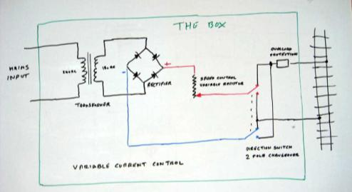

Fig 1. Variable current controller

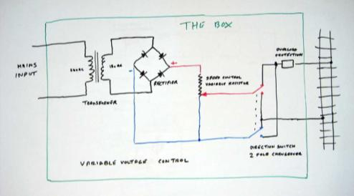

Fig 2. Variable voltage controller

## Allan Trotter

## Baguley-Drewry 009 kit

My latest project is a Baguley-Drewry 009 kit produced by Narrow Planet (ref no NPL-001) and represents a design of diesel locomotive built by Baguley-Drewry in the 1980s for use at Royal Naval Armaments Depot (RNAD) sites around the UK.

Two types of similar 2'6" gauge loco were built for the RNAD, the 99hp version, as represented here, and a smaller 60hp design which Narrow Planet intend to produce as a separate kit later. They are both of a four-wheeled diesel hydraulic layout with a large cab offering good visibility.

Following rationalisation of RNAD installations, disposal sales have resulted in many of these locos finding new homes at preserved railways around the country. Notable locations of the 99hp design include Whipsnade Zoo, the Statfold Barn Railway and the Talyllyn Railway. In the latter case the locos are intended to be regauged, with modifications to the cabs required to suit the Talyllyn loading gauge.

The kit is a mixed-media combination of a 3D printed body shell and etched nickel-silver detailing. A Kato N-gauge 11-104 chassis (more commonly referred to in 009 circles as the 'tram' chassis) is required to complete the model and can be fitted with minimal modifications.

The objective of the kit's design was to offer a simple to construct body, taking advantage of the fast pace of development in 3D printing technology, whilst retaining the level and fidelity of detail expected by today's narrow gauge modellers. It can be constructed with simple tools and superglue, no soldered assembly of the metal parts is required.

The kit retails at £30 and was one of the easiest kits I have built. Some photographs are shown below.

Mike Sharples

## C:\Users\Heather\Pictures\image.jpegC:\Users\Heather\AppData\Local\Microsoft\Windows\Temporary Internet Files\Content.IE5\OP2KAVZ8\image.jpeg

## Fig 3 The Parts Fig 4 Body shell and etch

## C:\Users\Heather\AppData\Local\Microsoft\Windows\Temporary Internet Files\Content.IE5\6ZNMPD8B\image.jpegC:\Users\Heather\AppData\Local\Microsoft\Windows\Temporary Internet Files\Content.IE5\N2GCCBJL\image (2).jpeg

## Fig 5 & 6 The completed kit

## 

## 

## Fig 7 The finished model

***********************

**Where’s Allan**

For the moment, the July photograph was the last in the “Where’s Allan” series. This one stated that there were “not too many clues other than to suggest that it might be a London station. Where was it, and more importantly, the date (year will be fine)? The answer was Paddington, London in April 1969.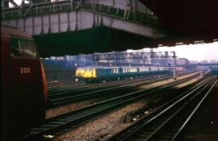

It's all go on the approaches to London Paddington. We have a couple of Warships on passenger trains and one of the Midland Blue Pullman trains recently transferred from London Midland Region to Western Region converted to work in multiple with its compatriot unit. (It looks like this is still the 6 car set although the midland Pullman logo on the motor car appears to have been painted out. – Ed)

***********************